Assignment

1.Draw and explain the architecture of 8086.[10M]

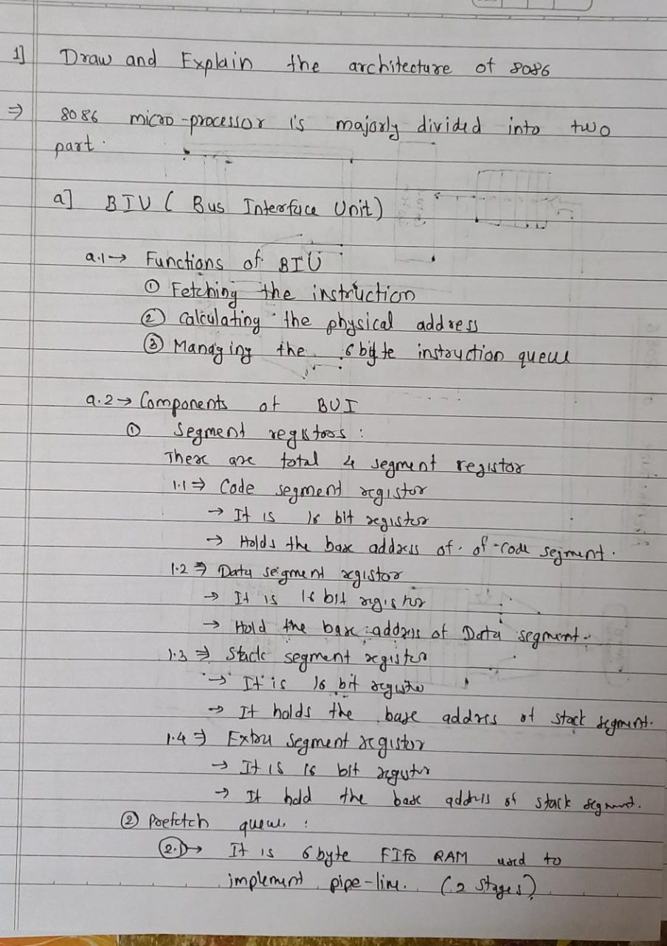

Ans. 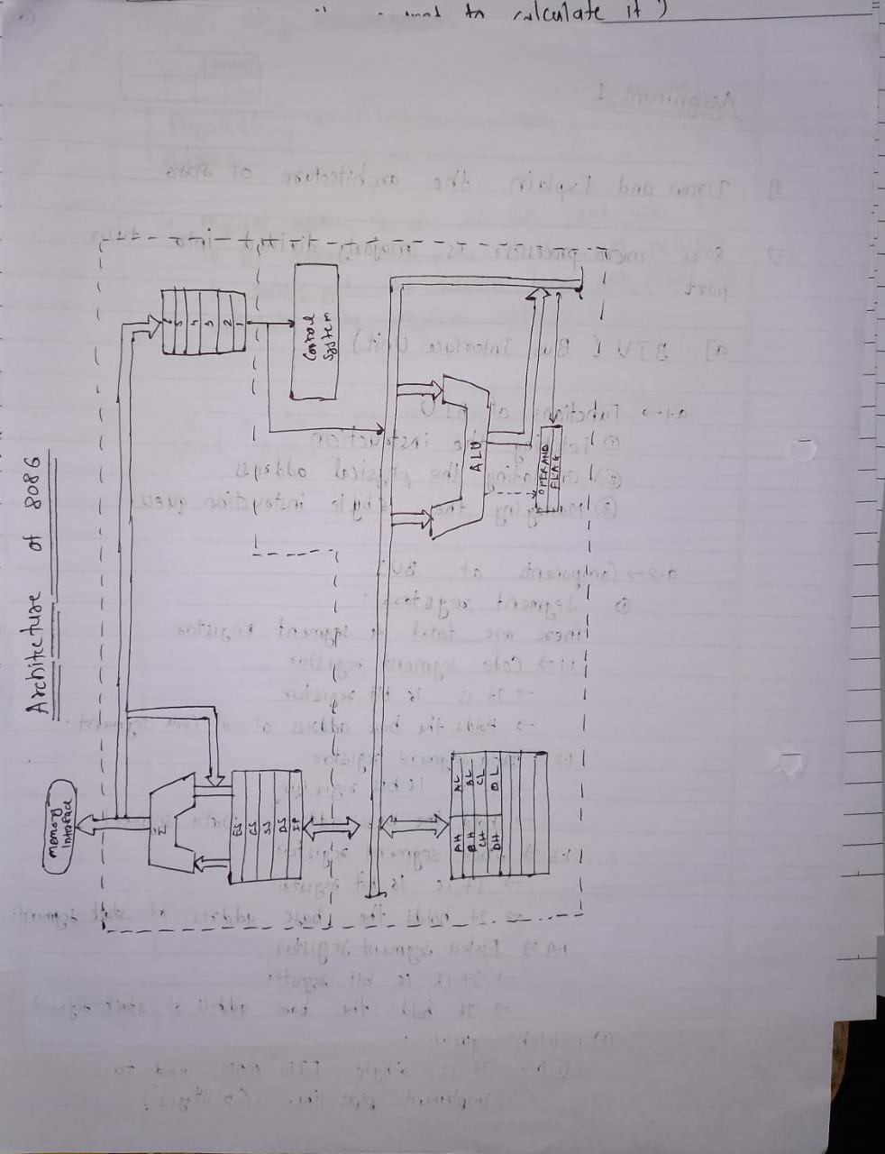

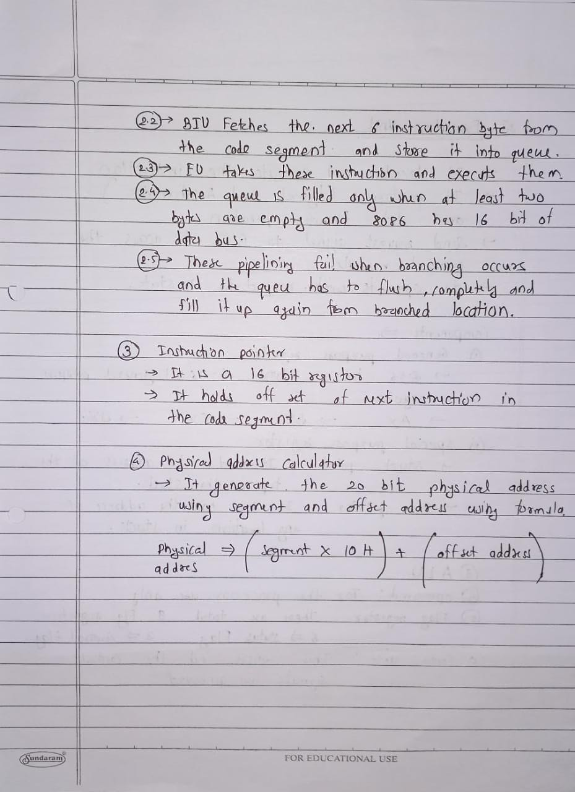

2.explain pre-fetch queue of 8086 [2M]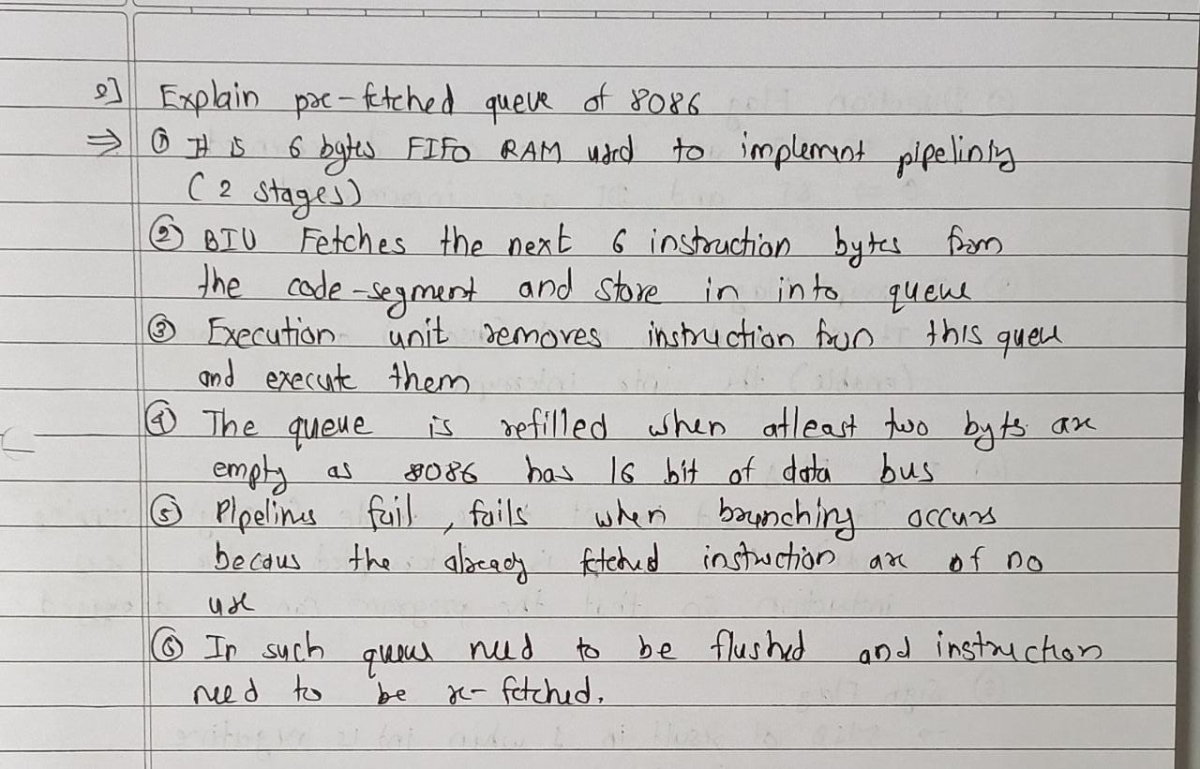

3.Draw and explain flag register of 8086.[10M] 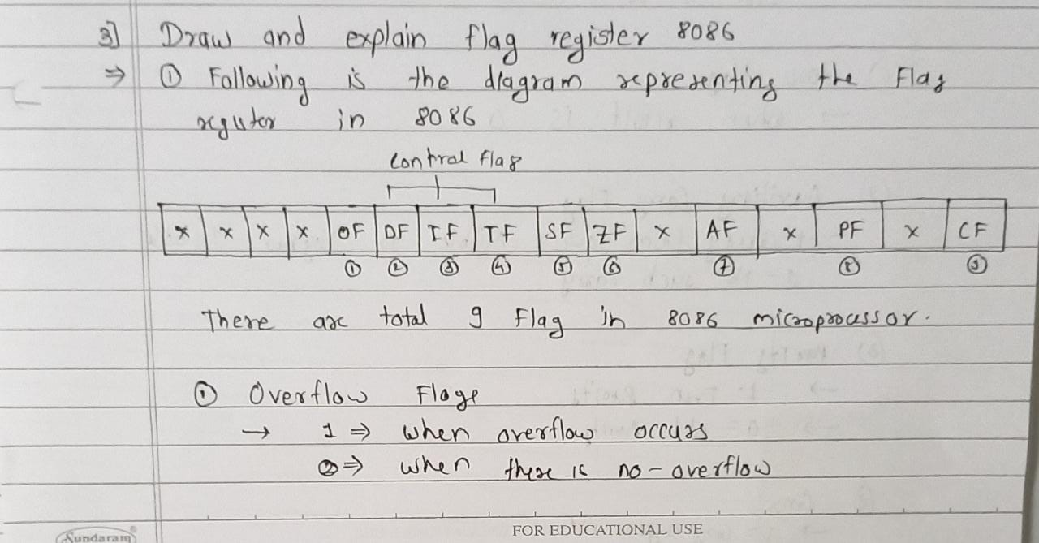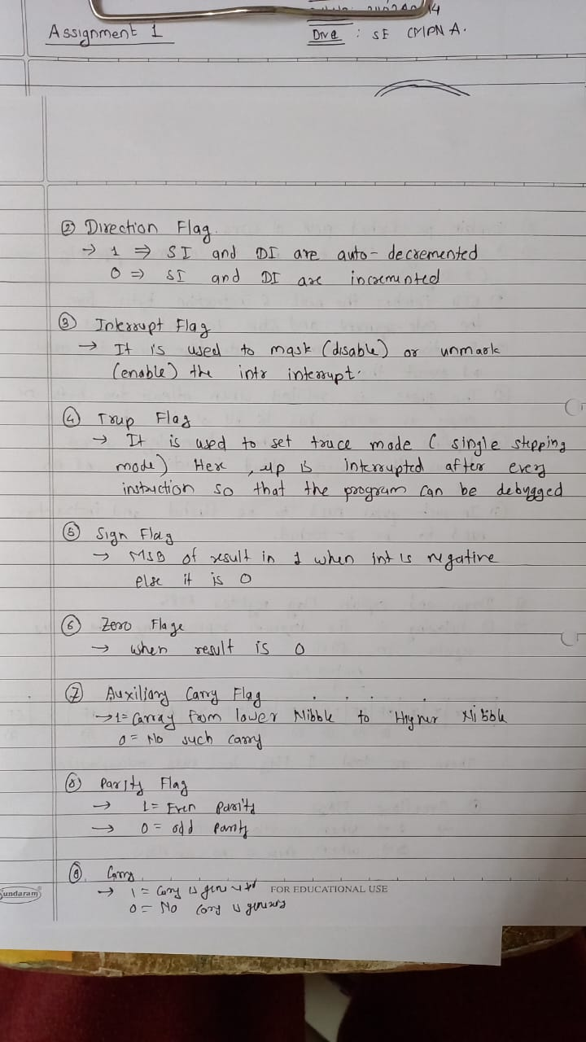

4.Write a formula to calculate physical address. And explain why its required to calculate it?[2M] 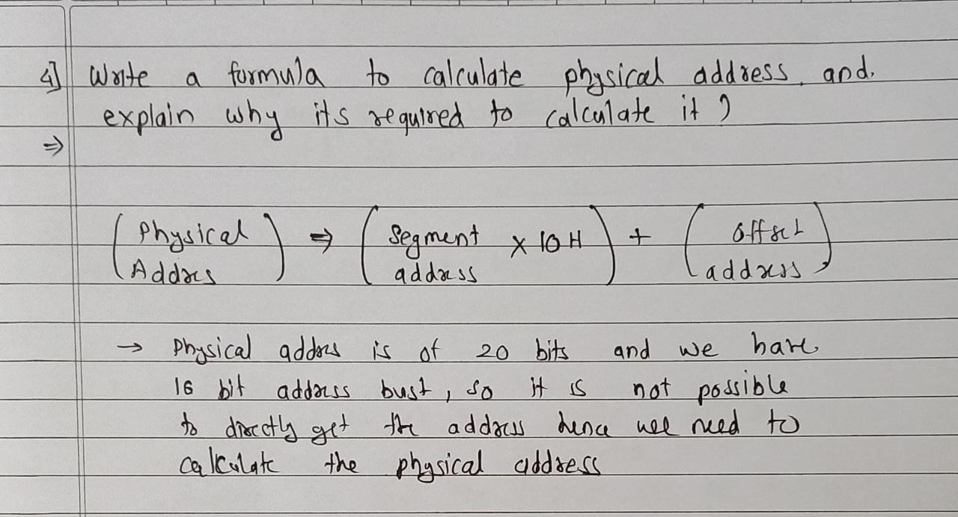

5. Write a note on addressing modes of 8086. [10M]

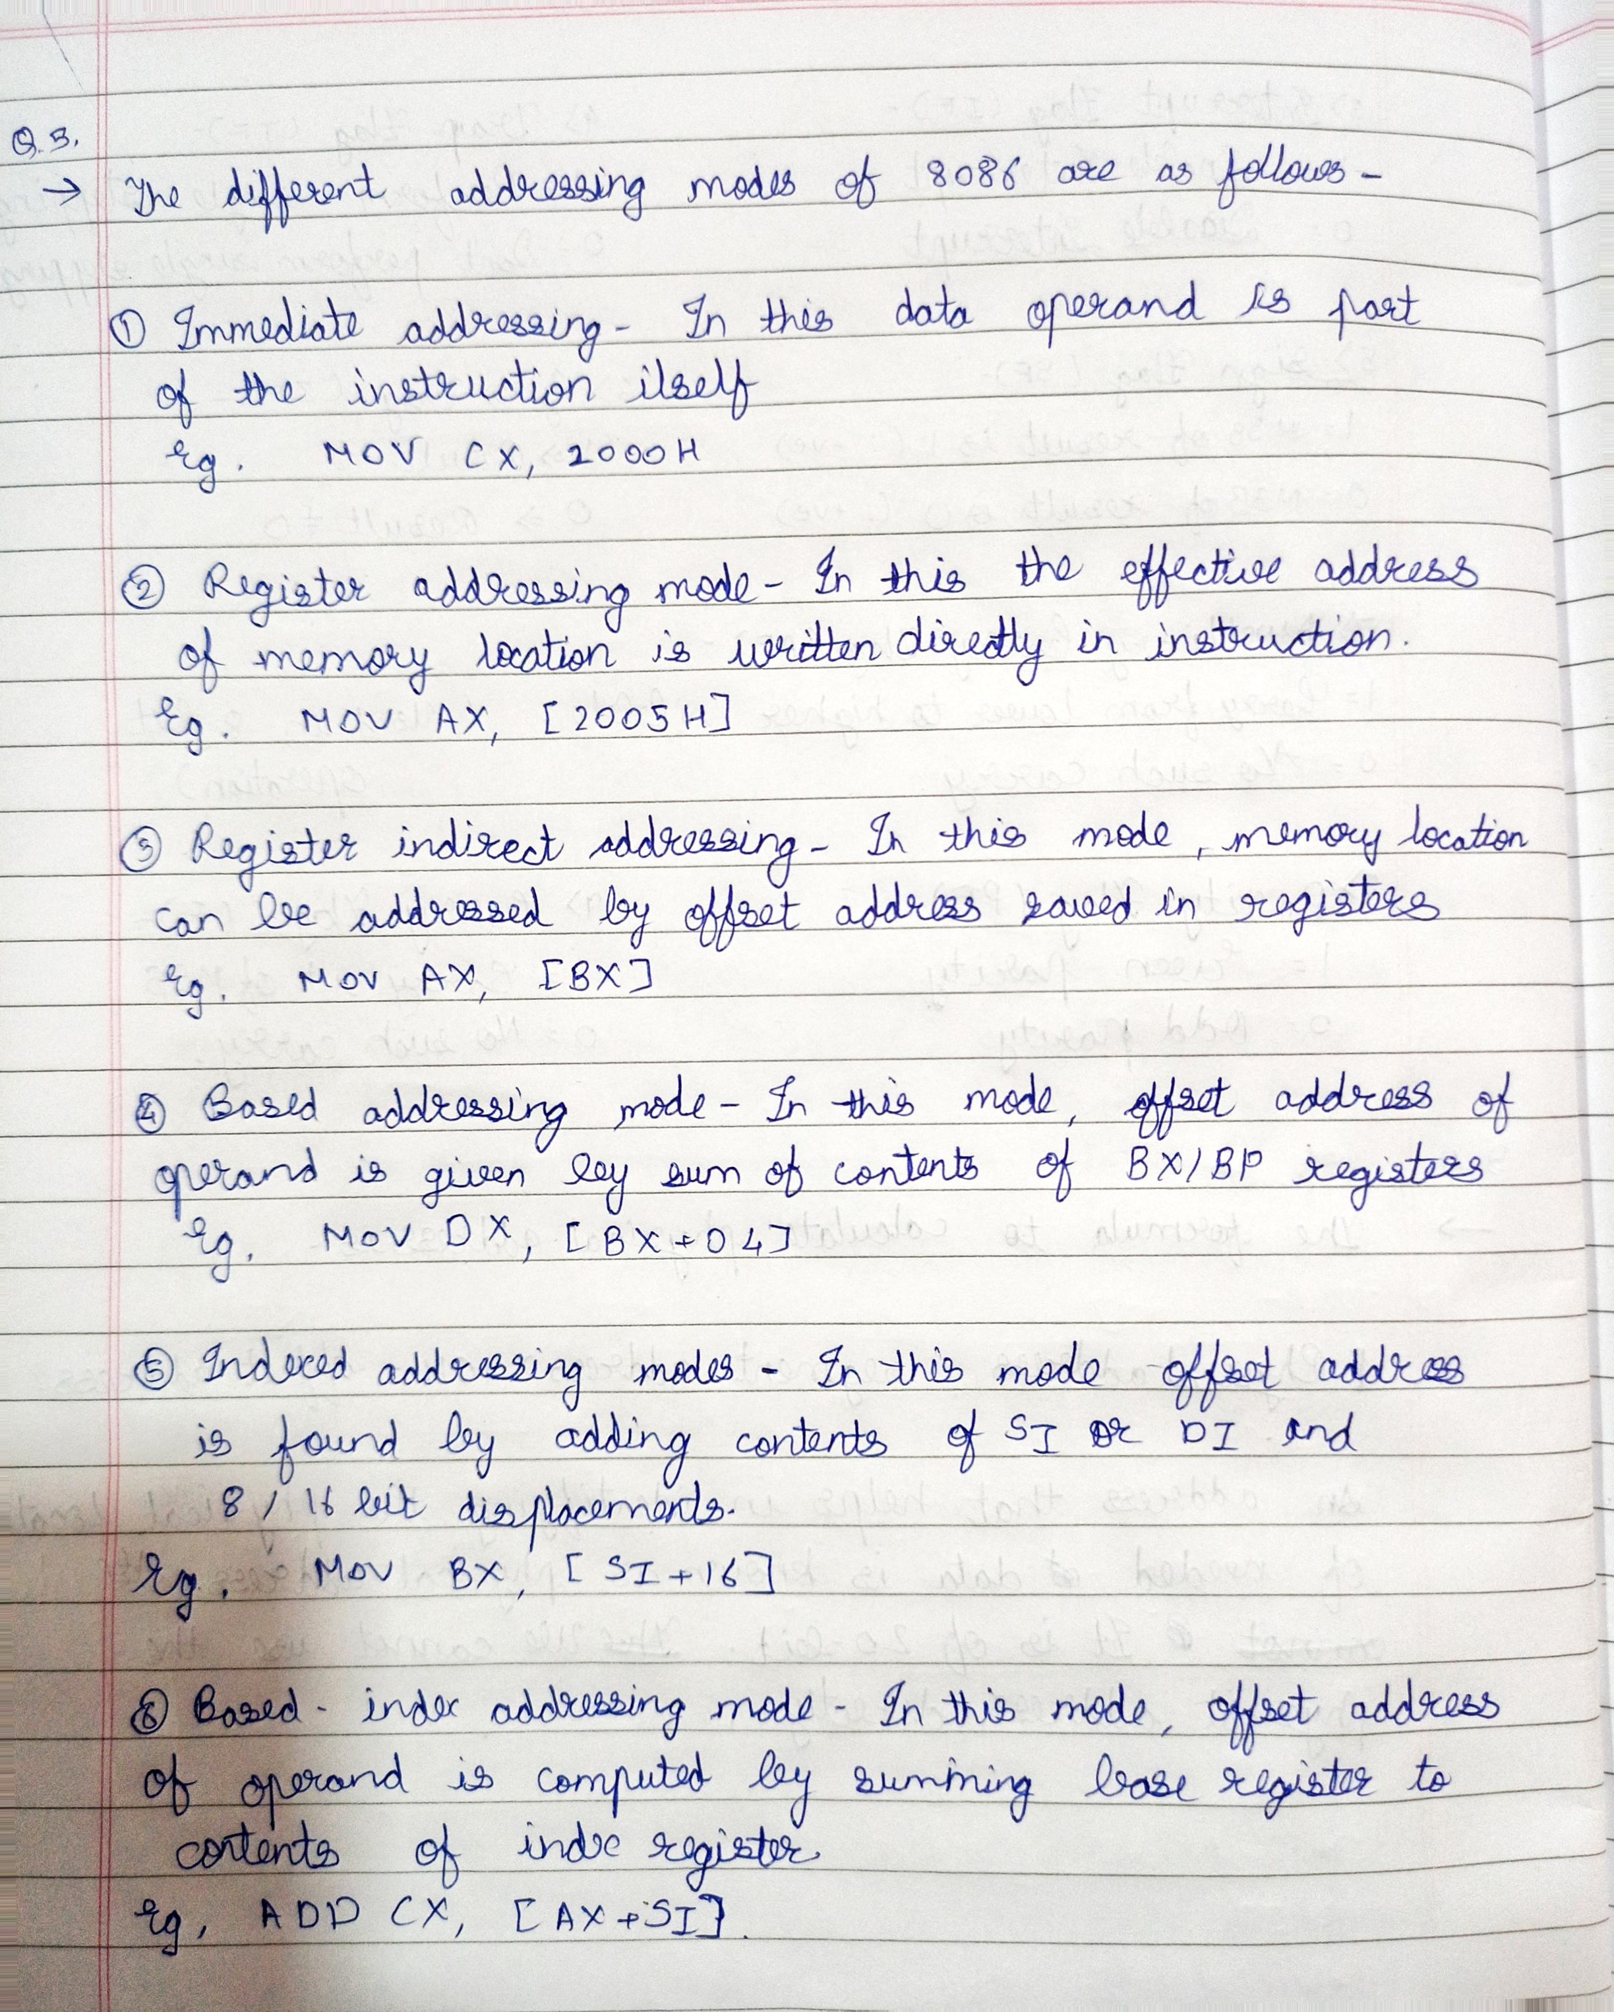

6. The instruction ‘MOV BL,[SI]’ comes under which type of addressing mode [2M]

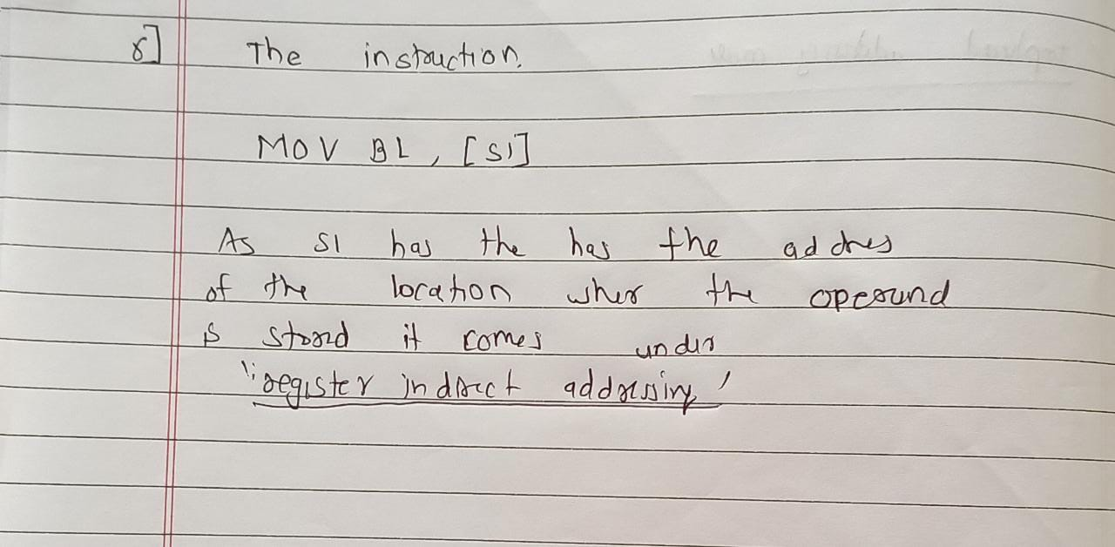

7.Design the power on reset and manual reset circuit for 8086 processor. [5M]

8.What is de multiplexing of address and data bus also explain the significance of ALE pin[5M]

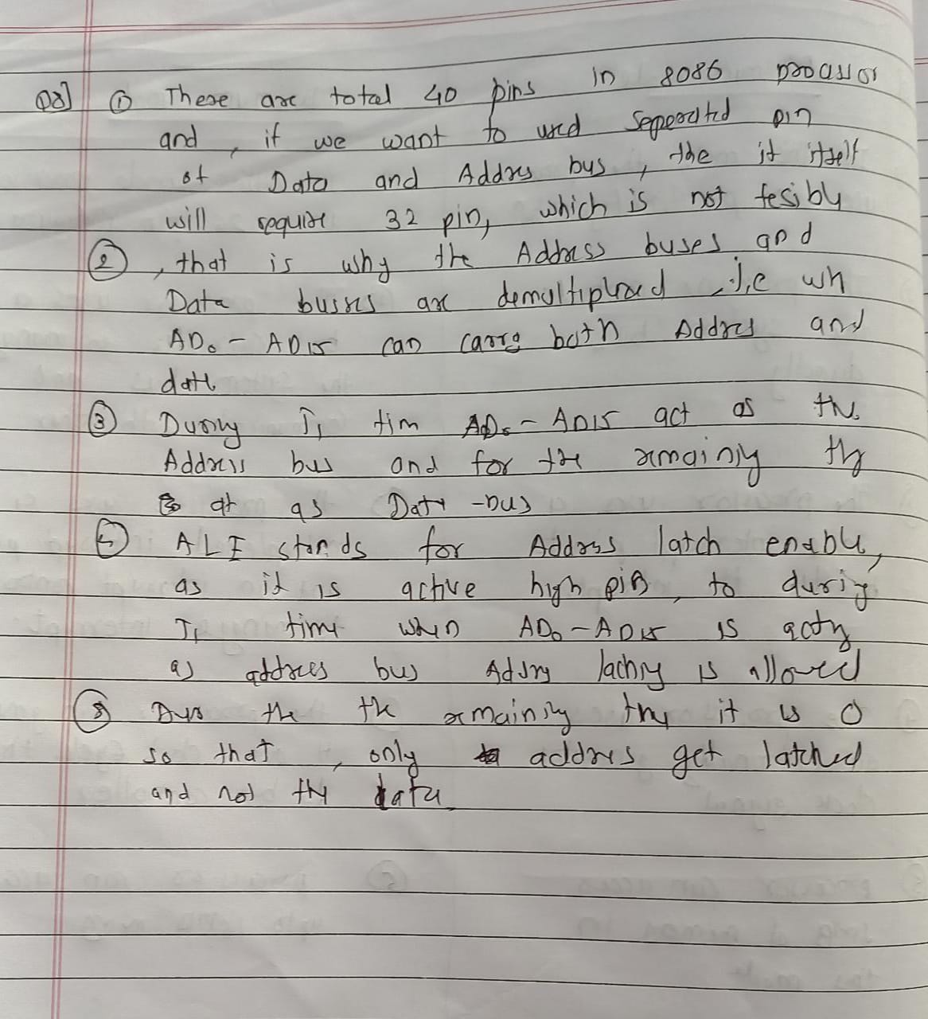

9.Why 8284 is needed in 8086 based system?[5M]

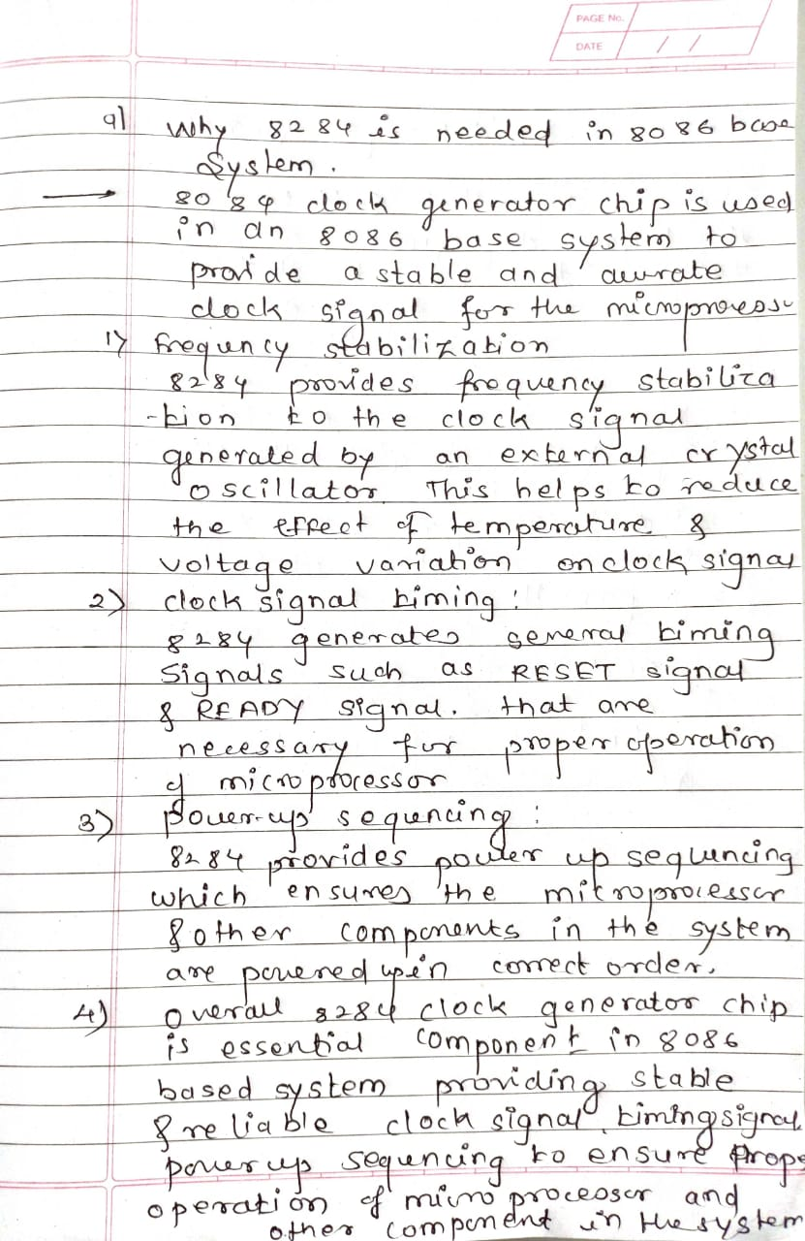

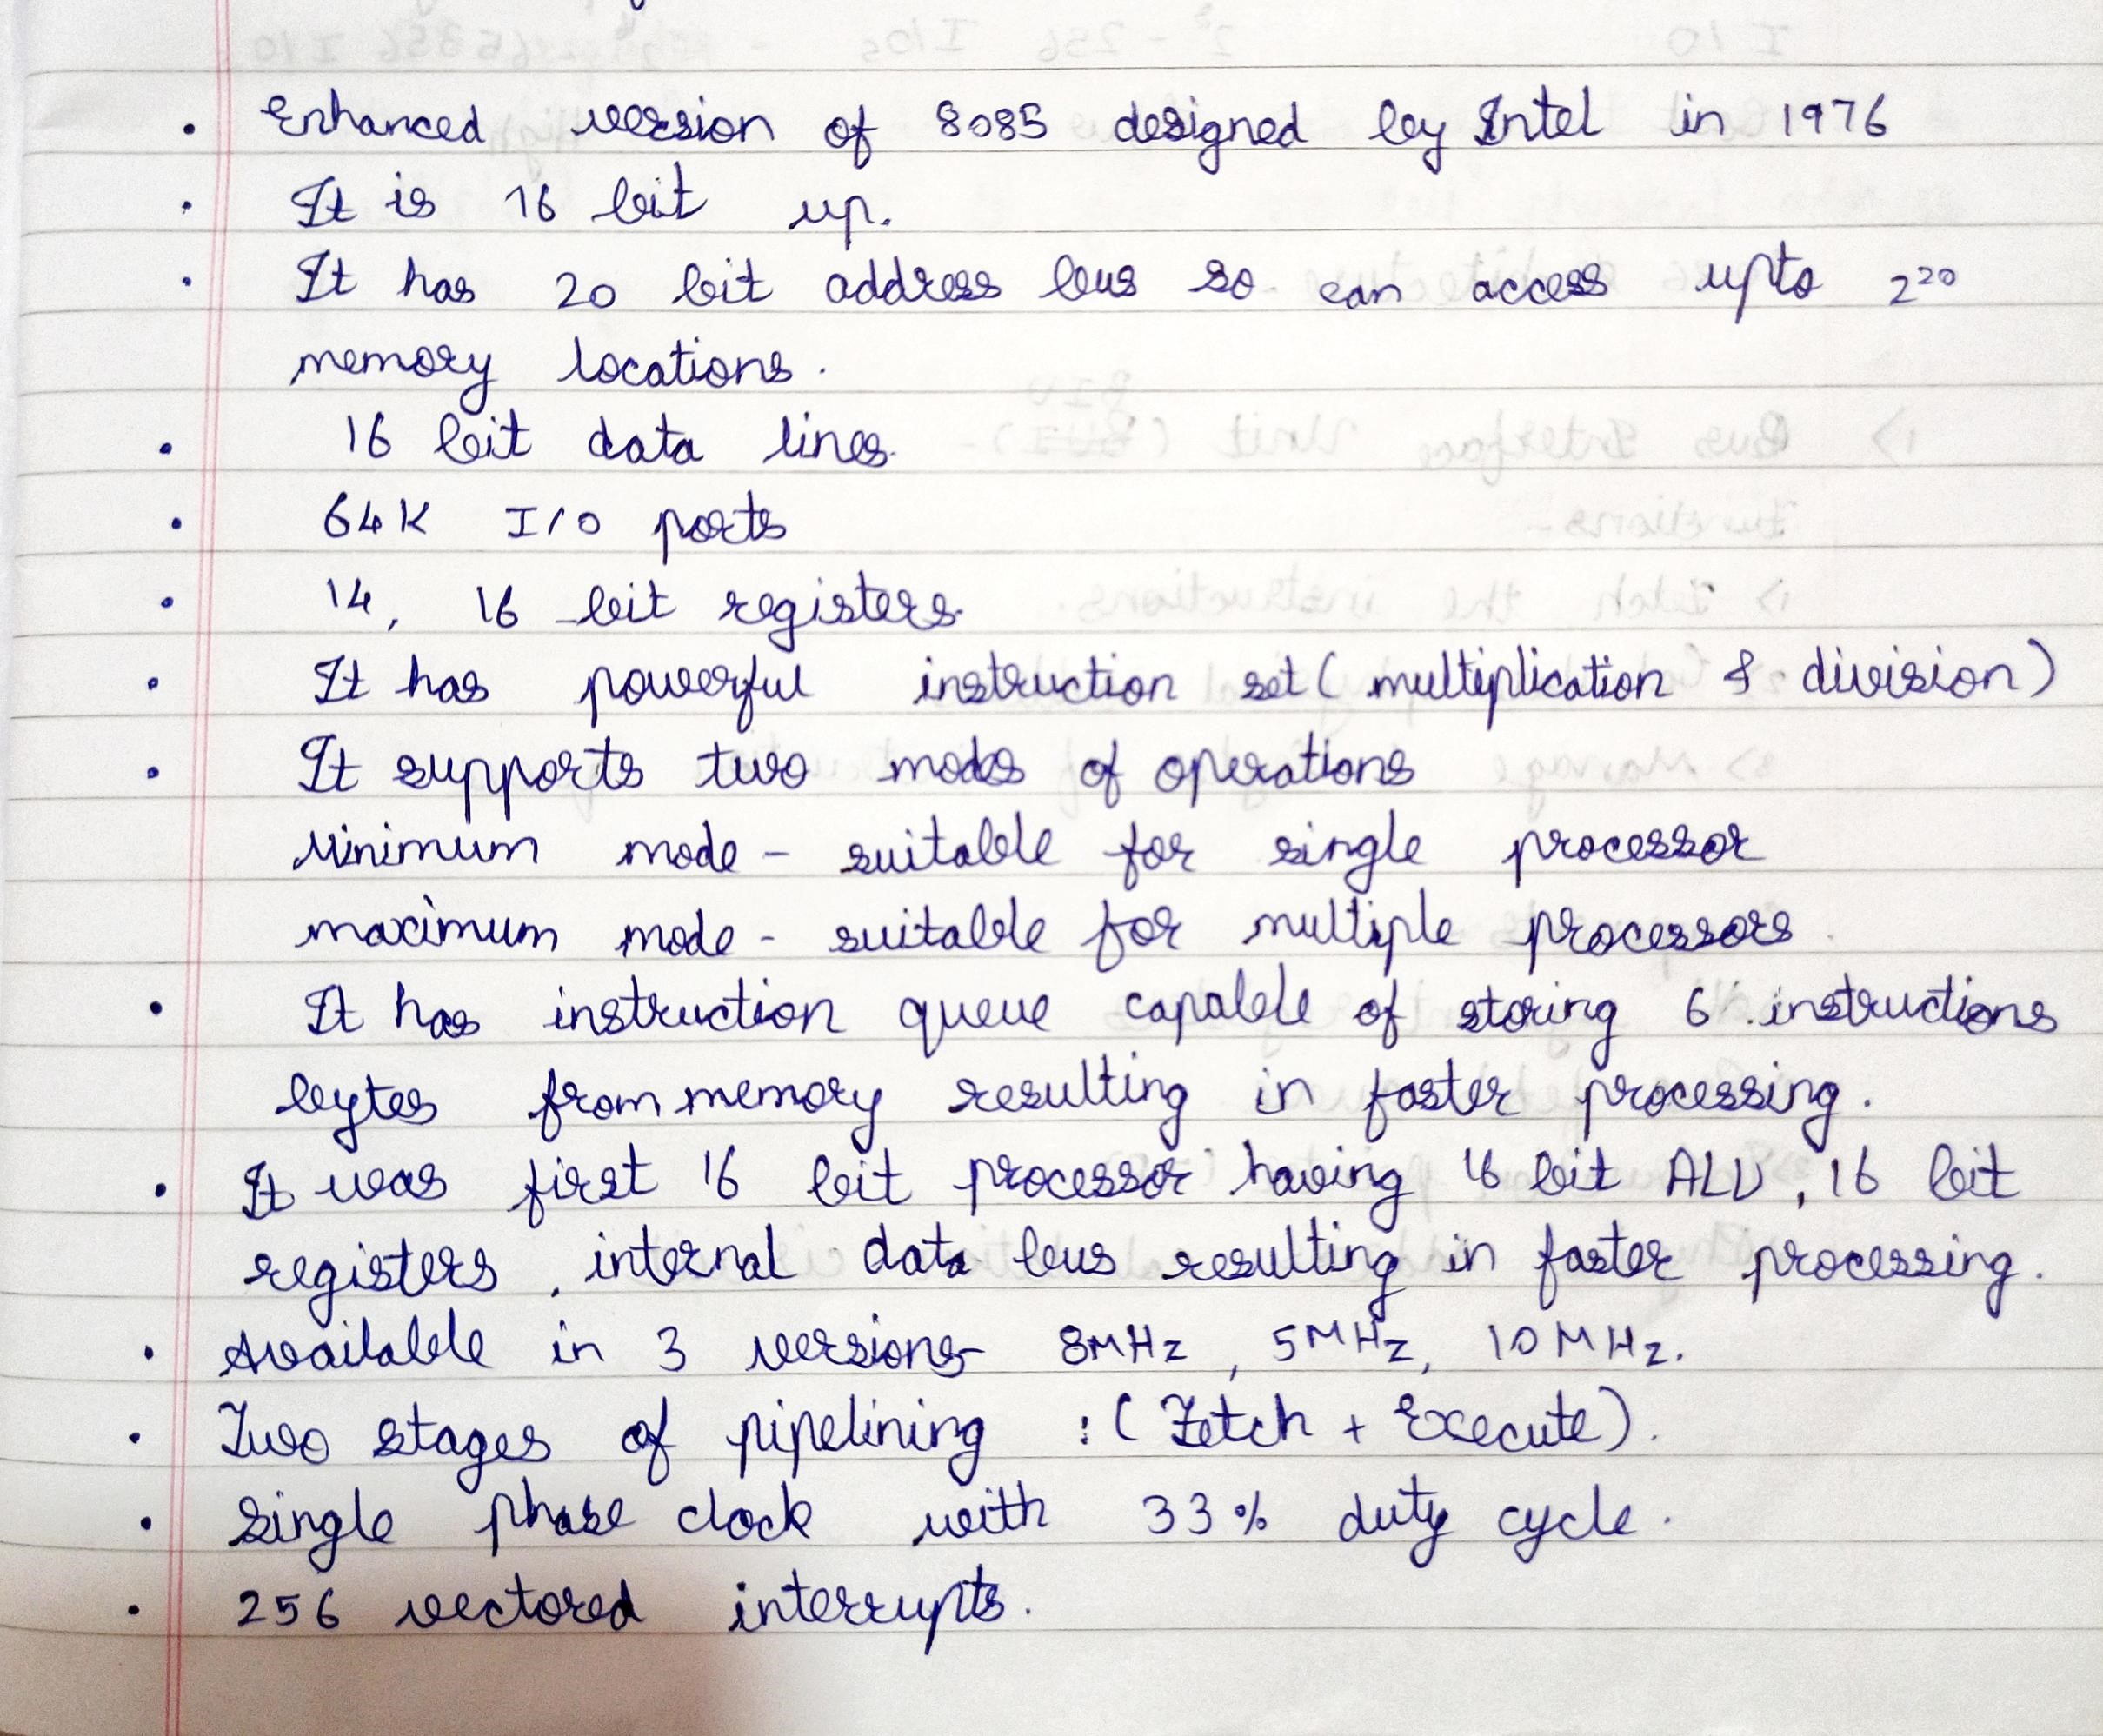10.List Features of 8086 microprocessor[5M]

11.What is the memory addressing capacity of 8086 ? and why?{2M]

->The 8086 processor has a memory addressing capacity of 1MB, which means it can address up to 2^20 (1,048,576) unique memory locations.

This memory addressing capacity is a result of the 8086's architecture, which uses a 20-bit address bus to communicate with memory. Each memory address can represent a unique memory location, and with 20 bits, the 8086 can address up to 1MB of memory.

12.Explain memory segmentation in 8086 and list its advantages[10M]

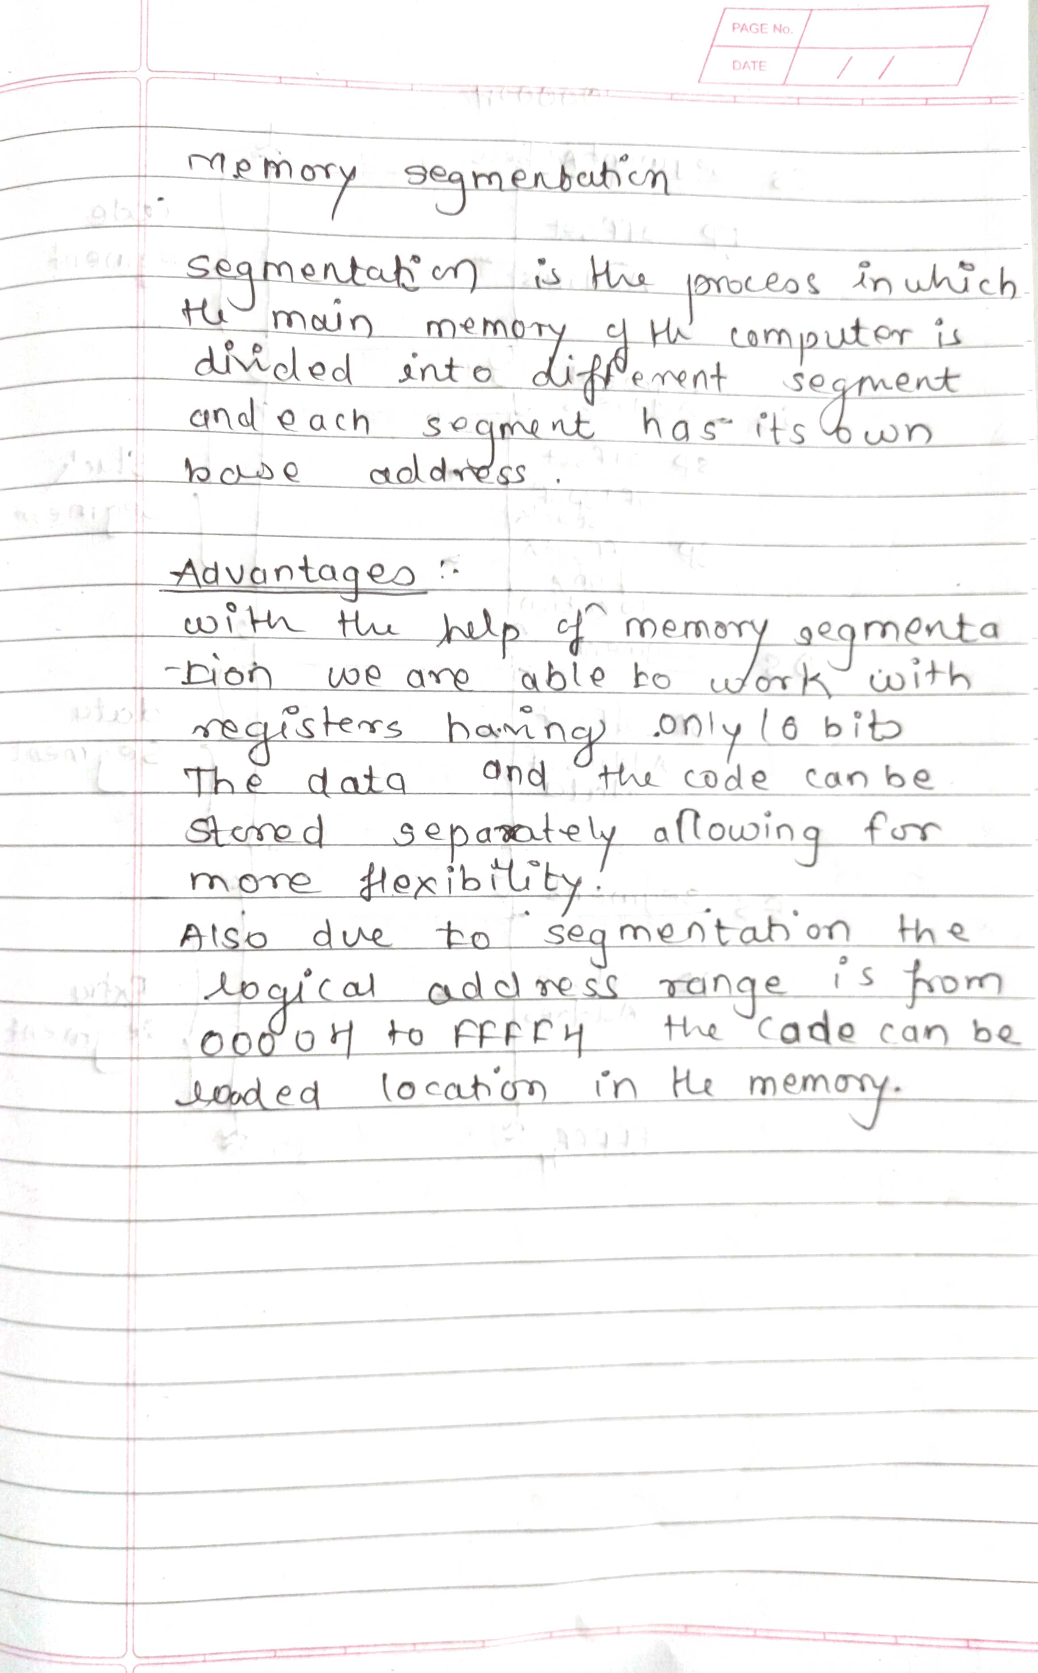

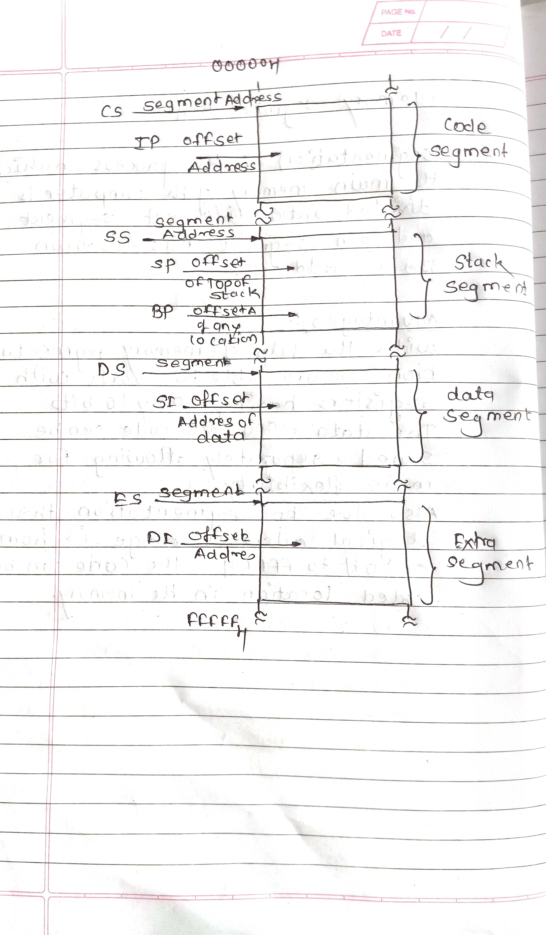

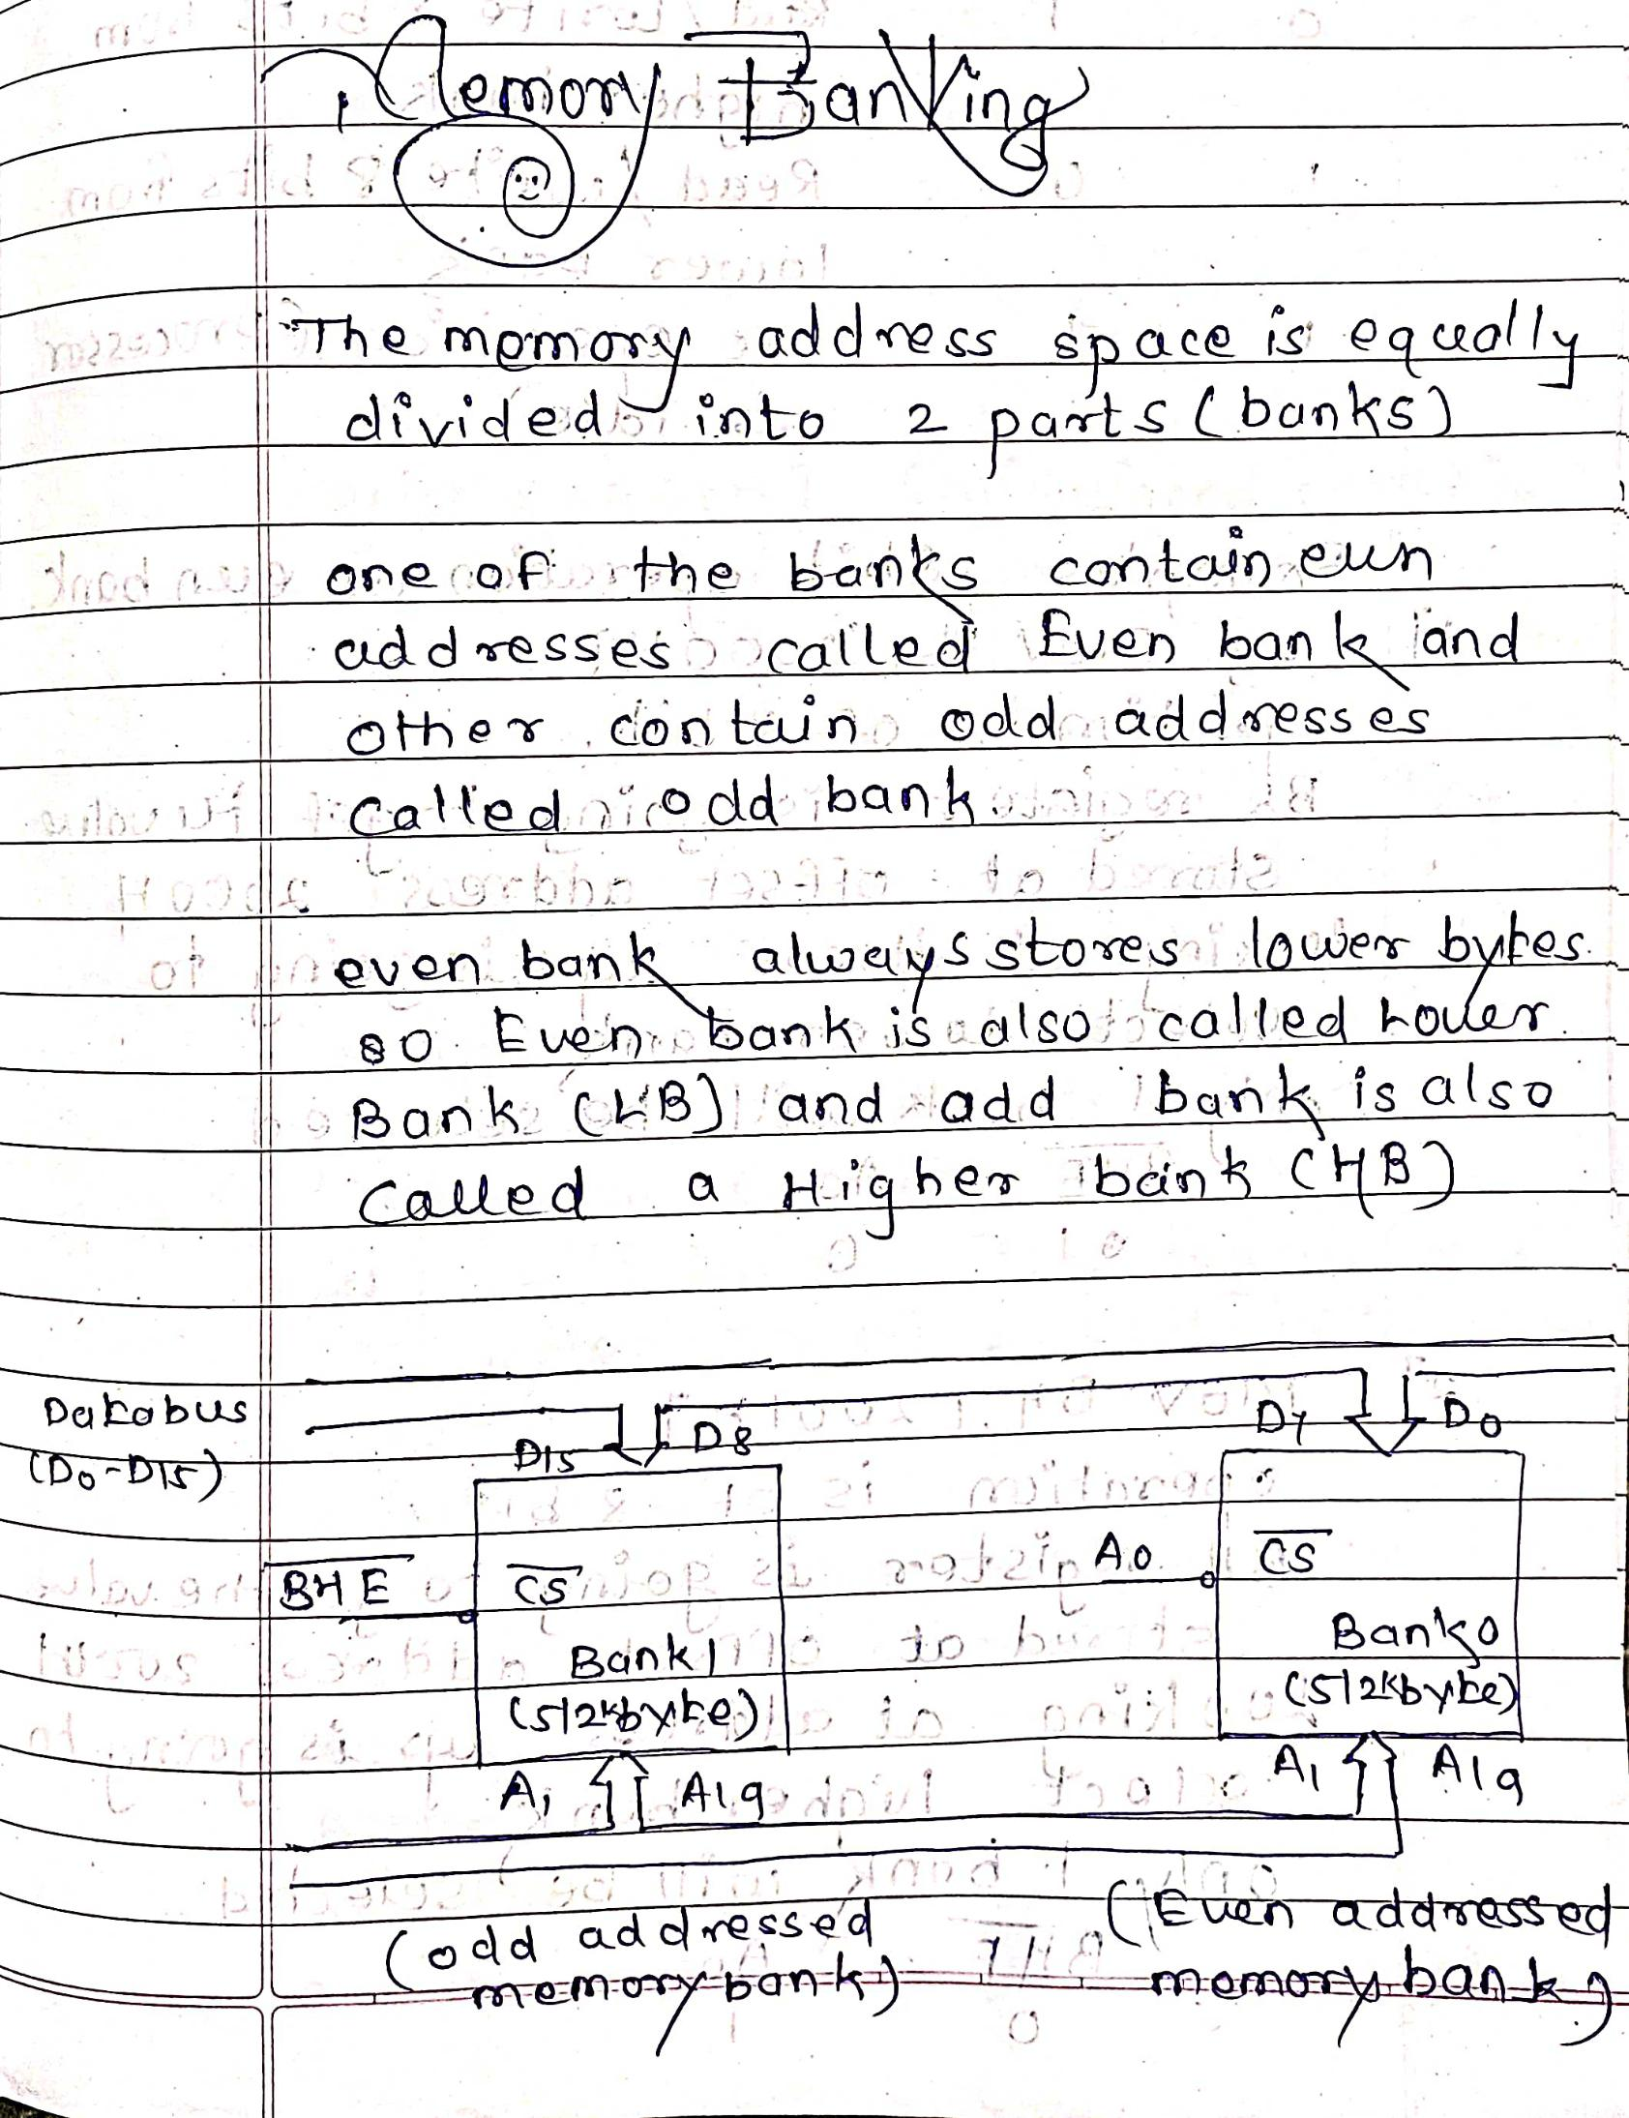13.Explain memory banking in 8086 system and describe its advantages. [10M]

14. Explain minimum mode of operation. [10M]

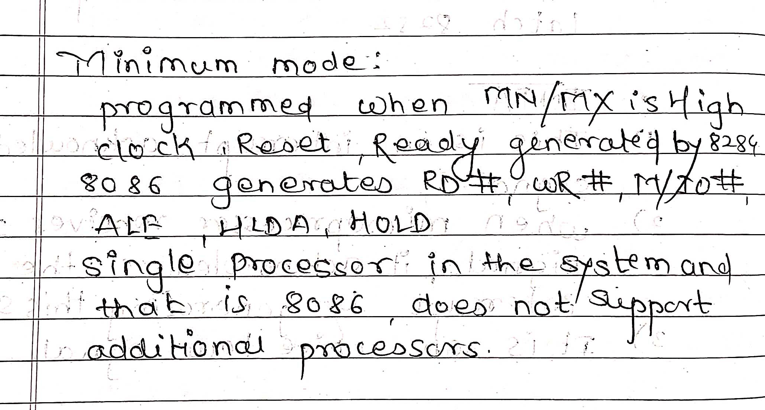

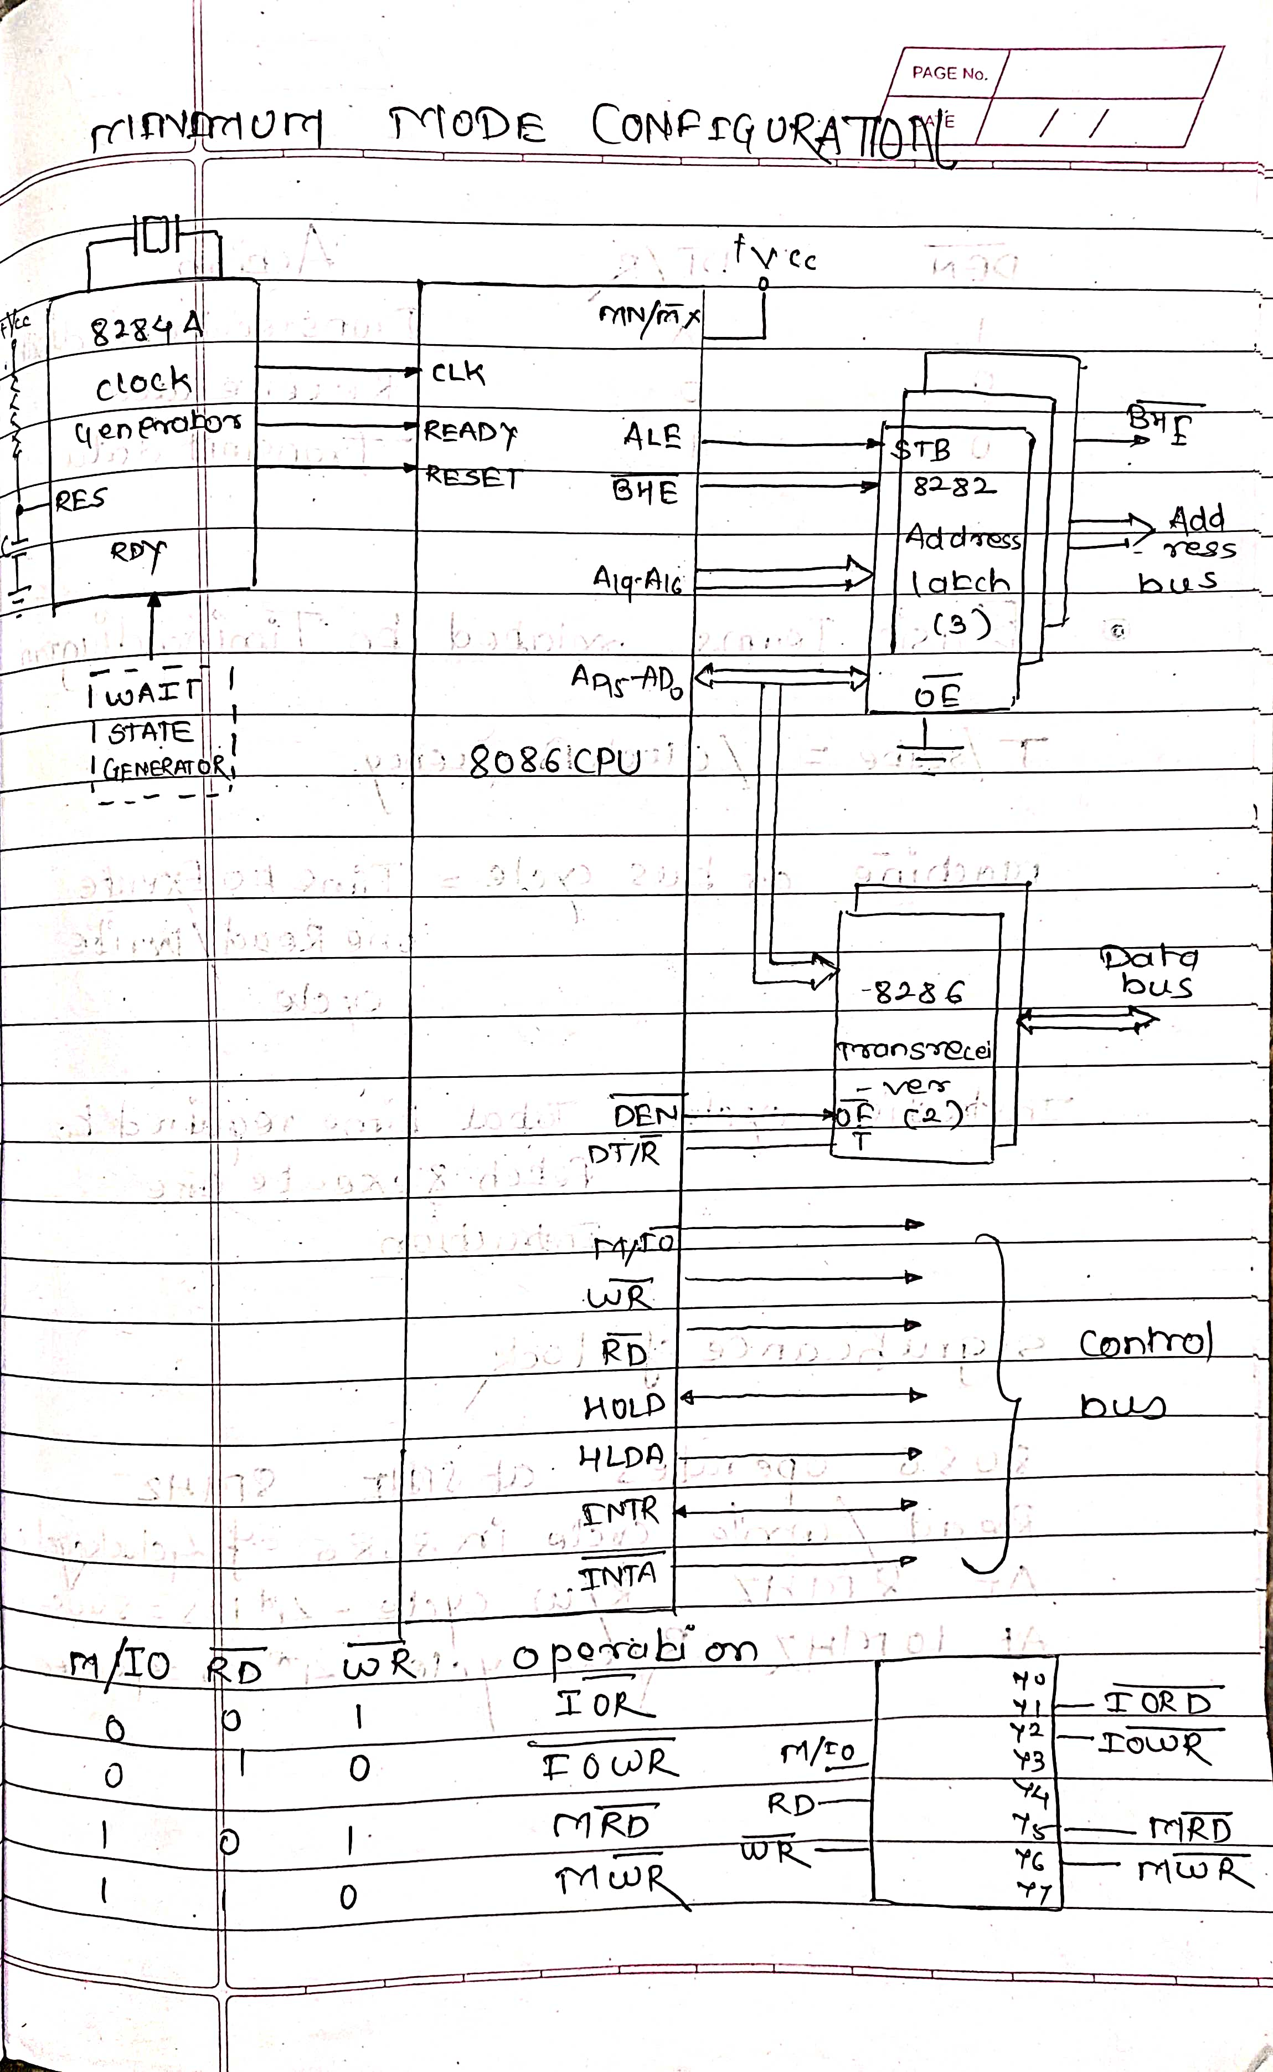

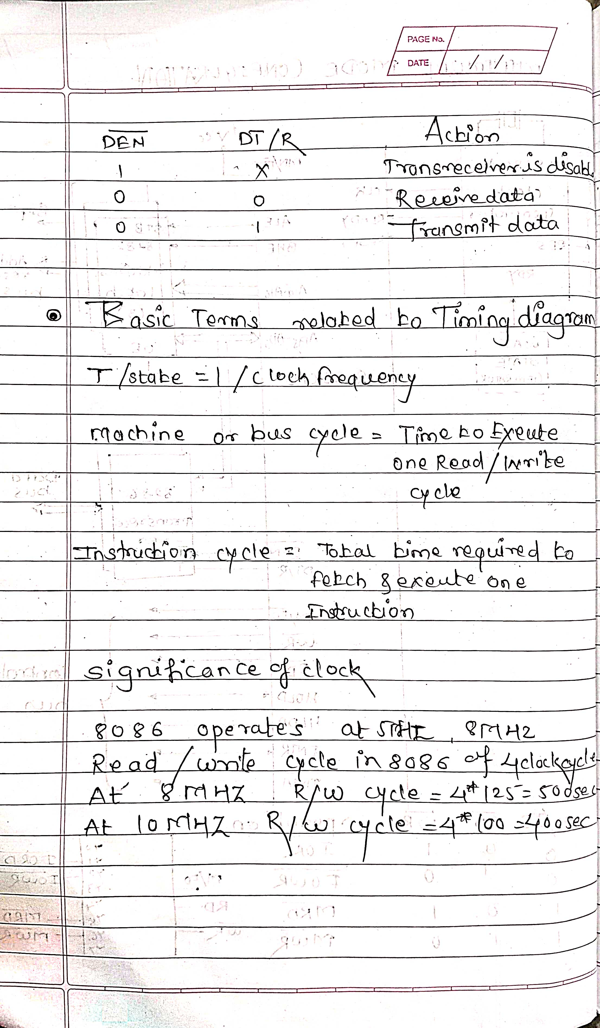

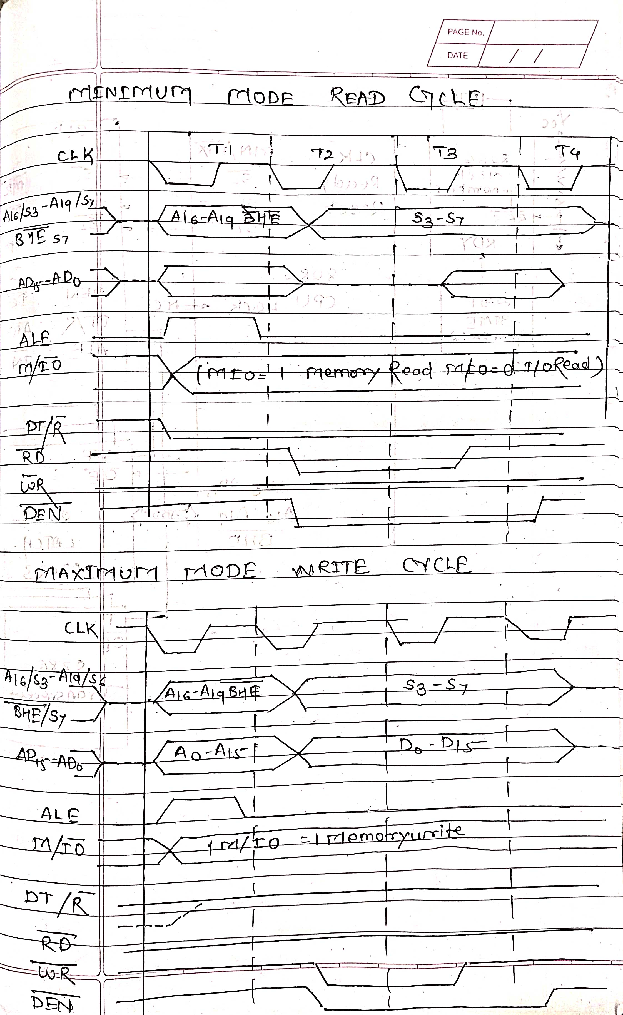

15. Explain maximum mode of operation. [10M]

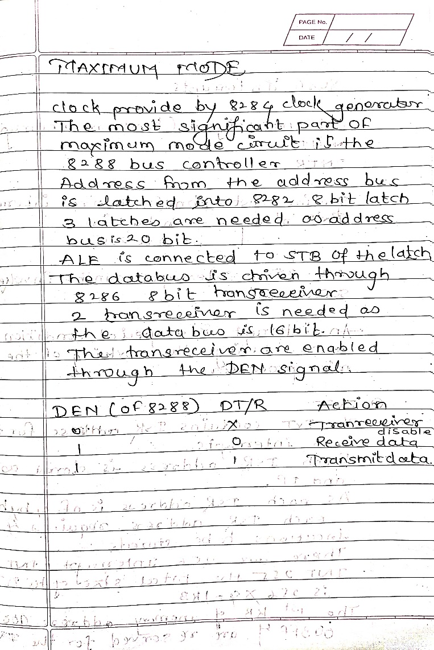

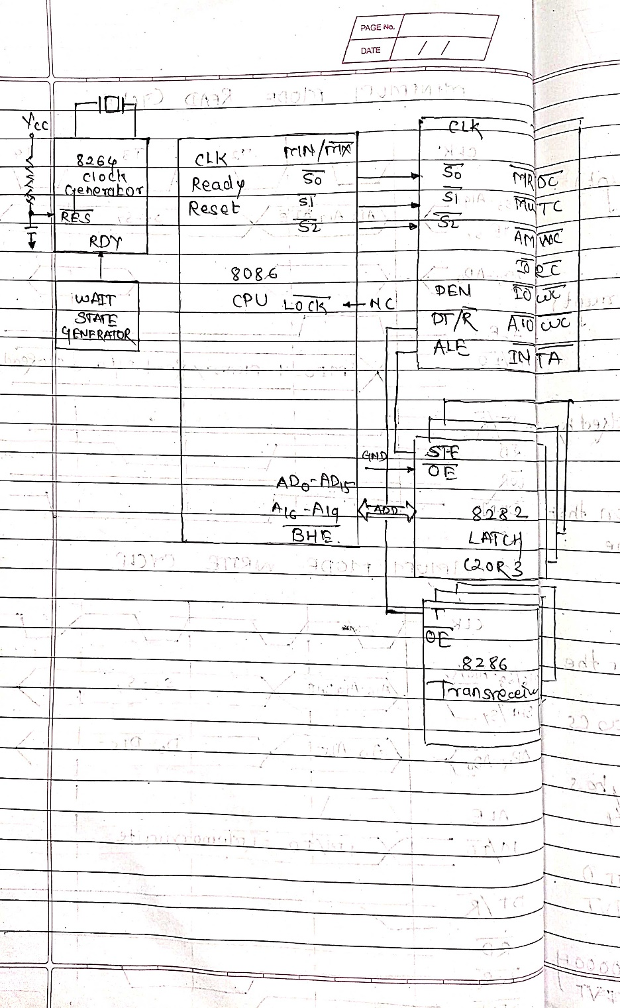

16.Draw and explain timing diagram for RD/WR operation in minimum mode of 8086.[5M]

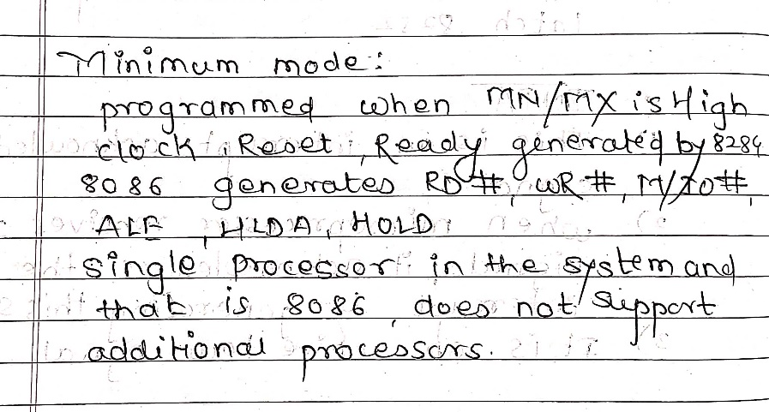

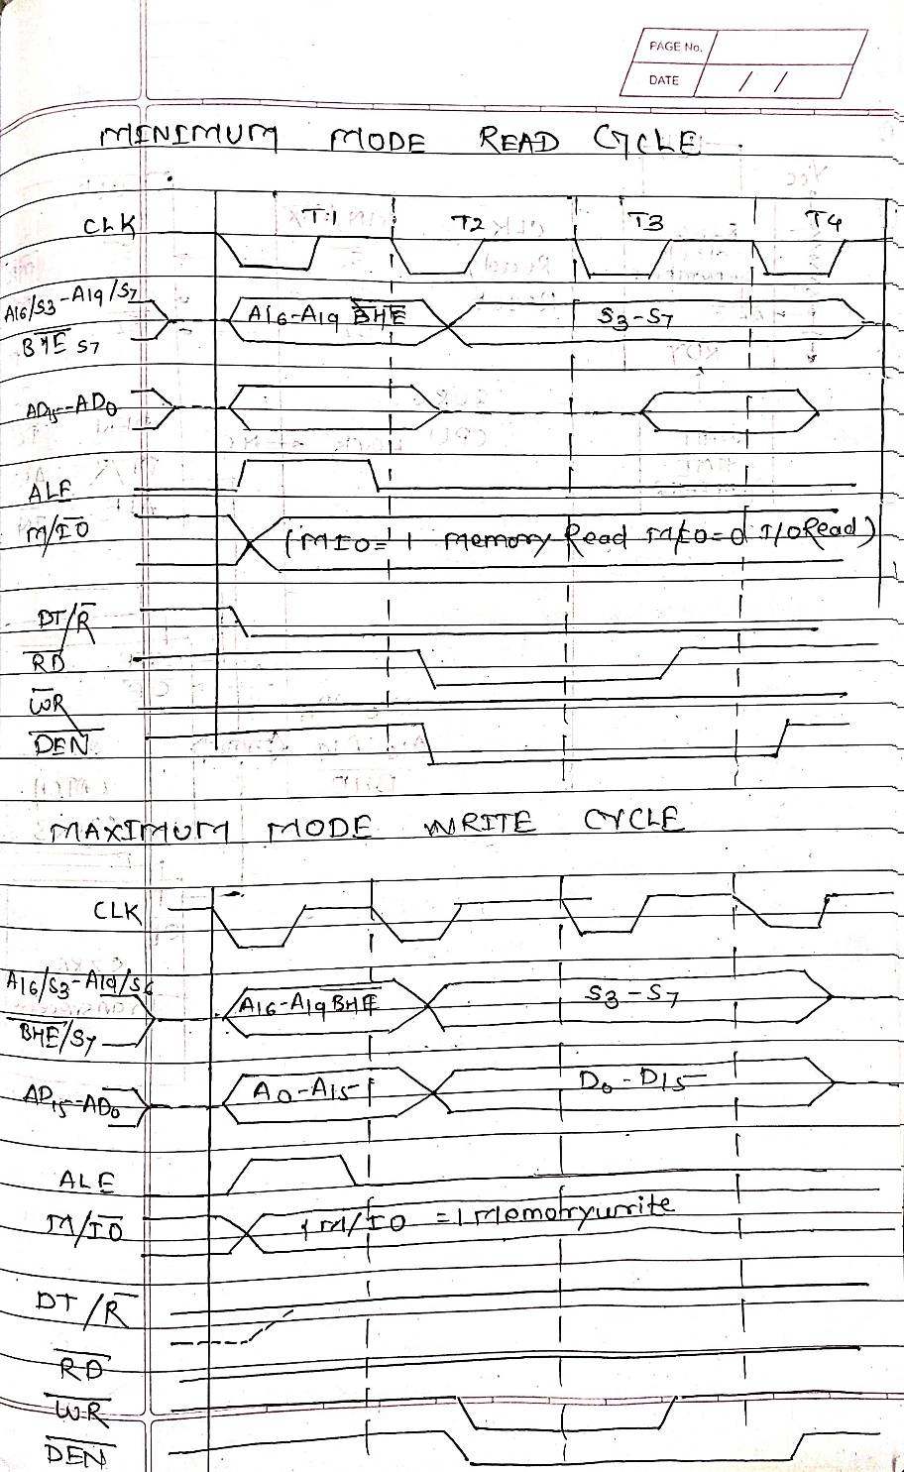

17.Draw and explain write/read operation timing diagram for maximum mode. [5M]

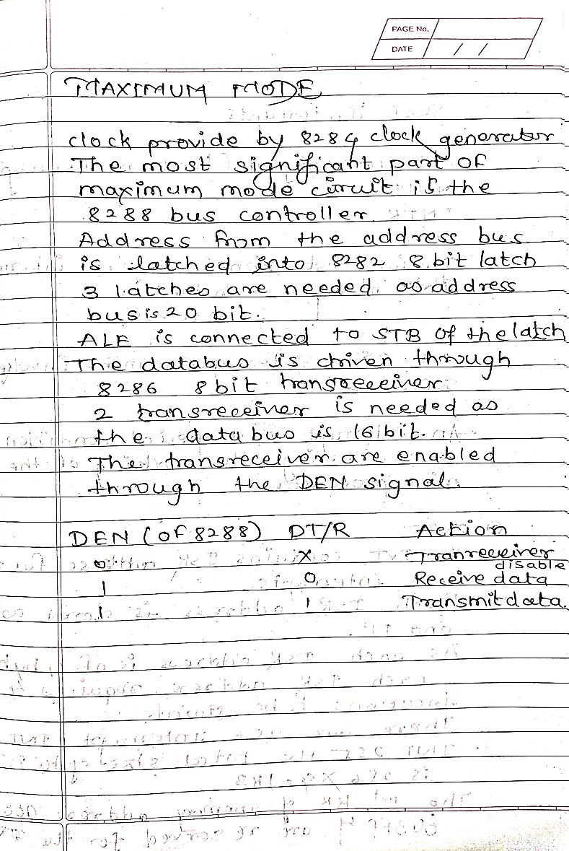

Diagram of write/read operation timing diagram for maximum mode

18.Differentiate between minimum mode and maximum mode of 8086. [5]

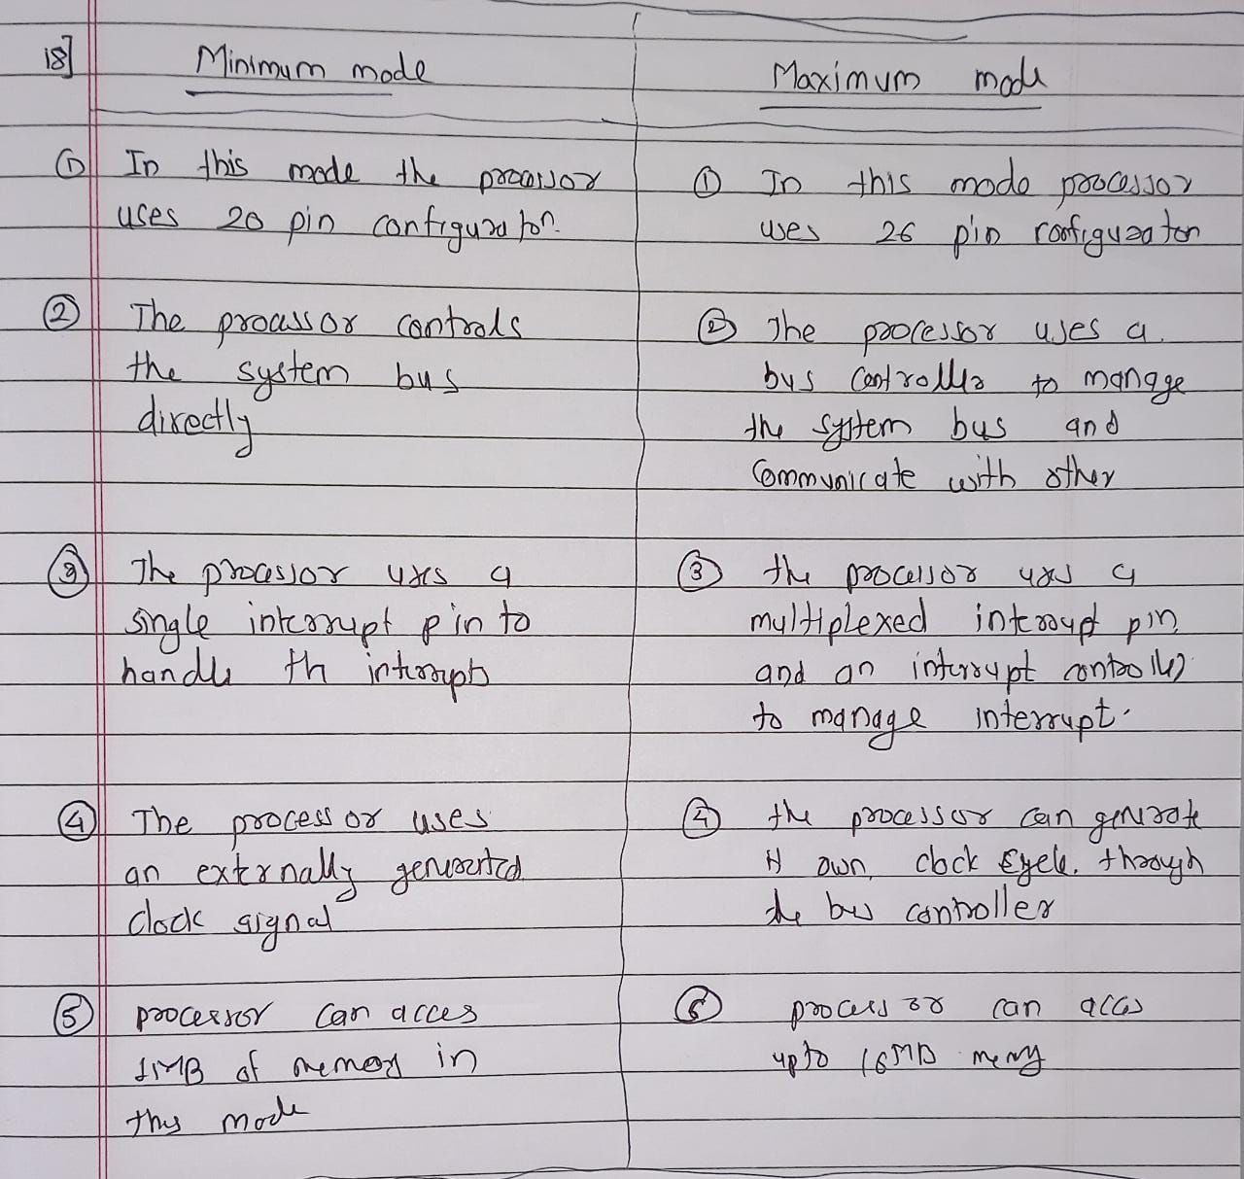

19. Explain types of interrupts. [10M]

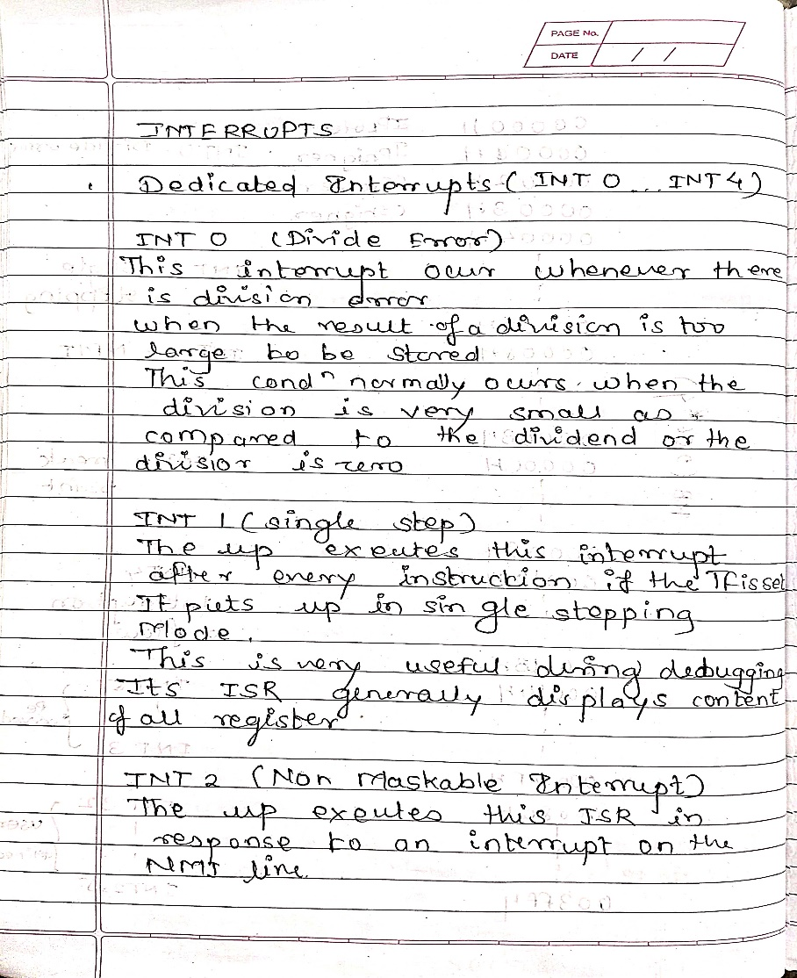

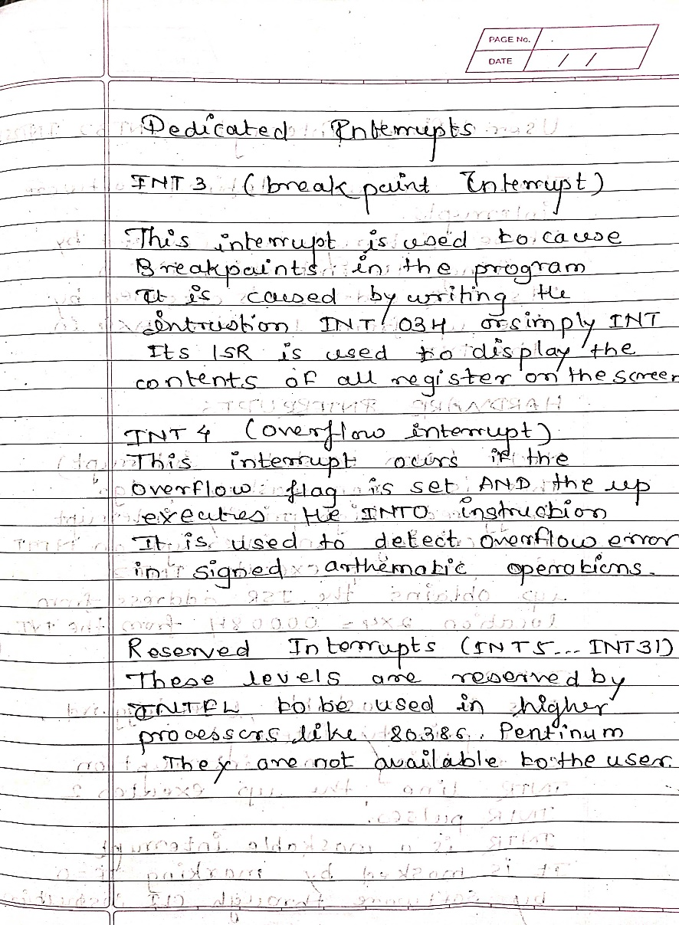

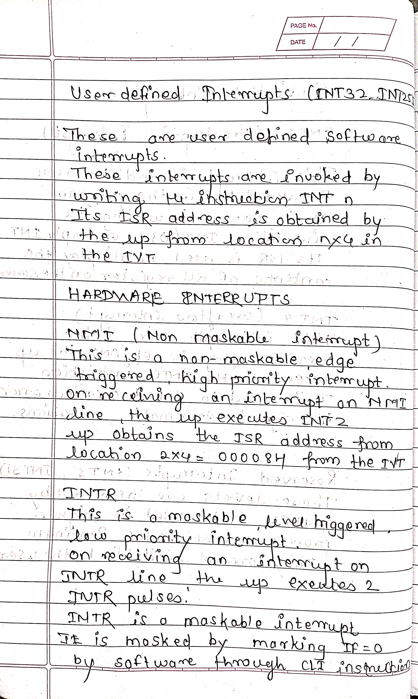

20. Design the power on reset and manual reset circuit for 8086 processor. [5M]

🡪REPEATED

21. What is de multiplexing of address and data bus also explain the significance of ALE pin [5M]

🡪REPEATED

22.Why 8284 is needed in 8086 based system?[5M]

🡪REPEATED

23.Explain interrupt vector table. [10M]

Ans.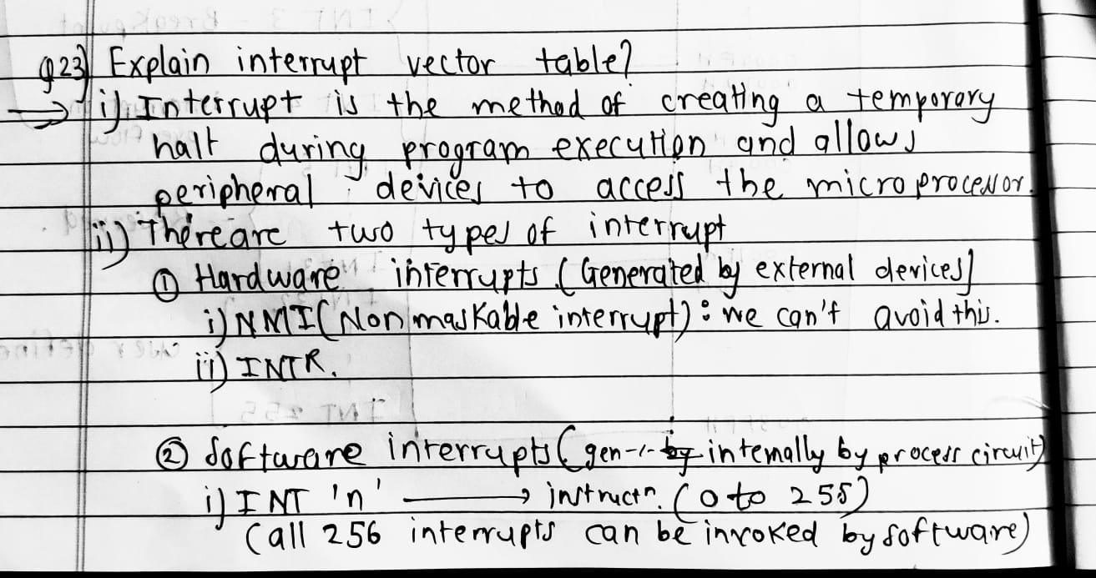

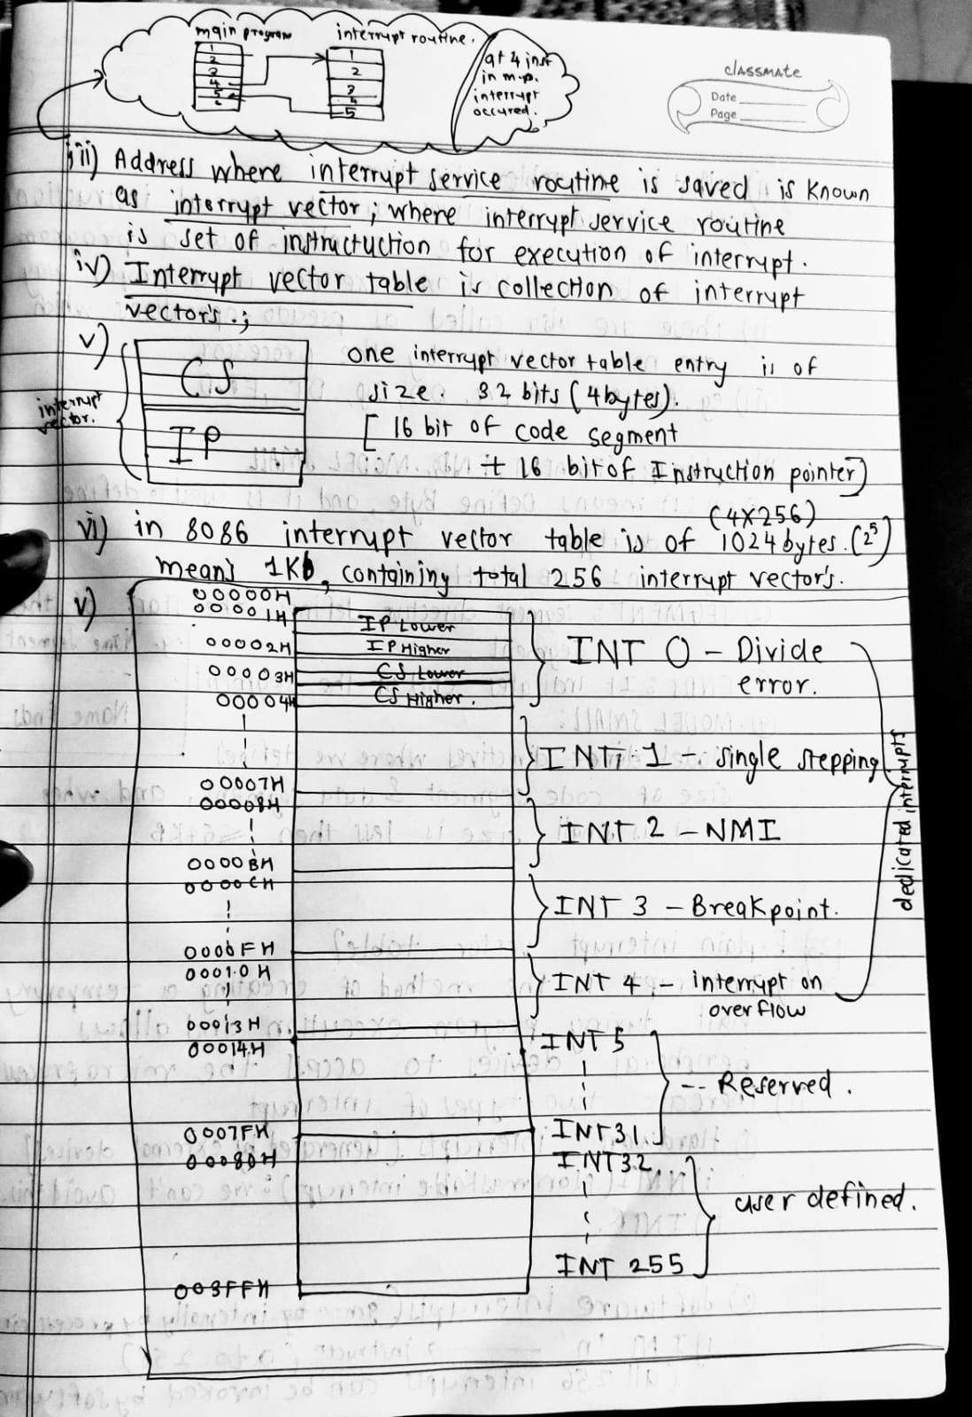

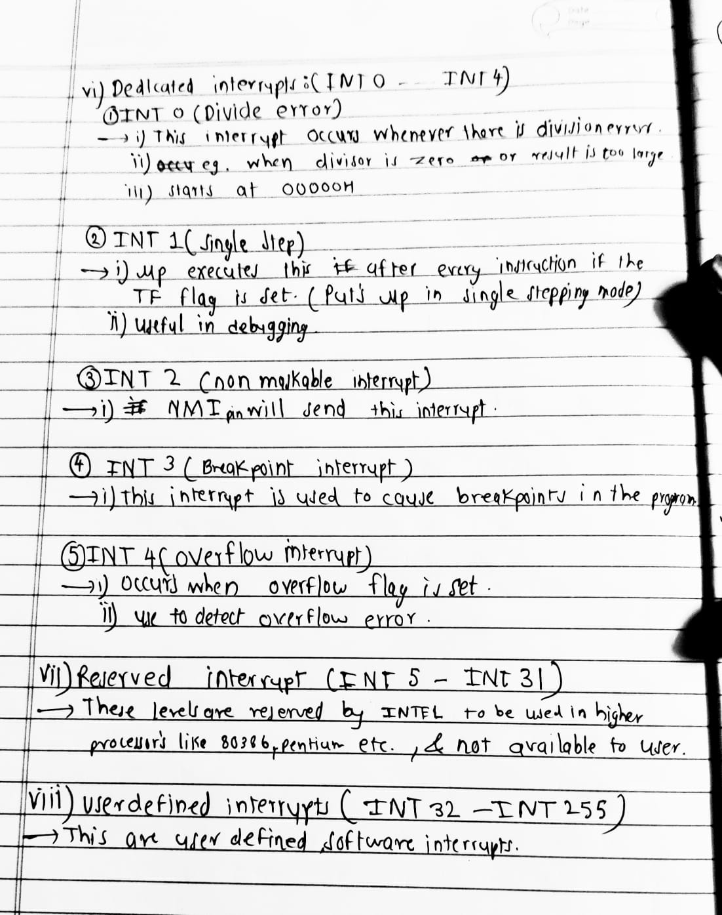

24.Explain following instruction:[10M]

a.DAA

c.XLAT

d.LAHF

e.LAHF

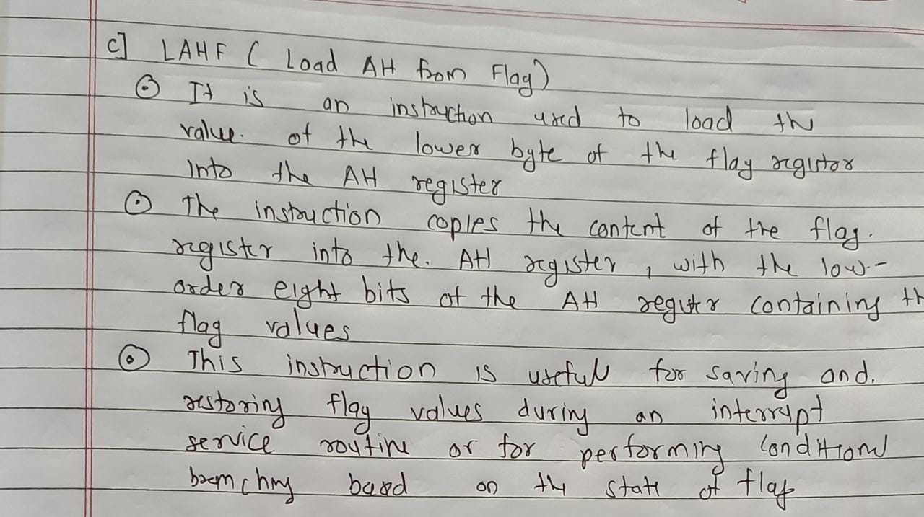

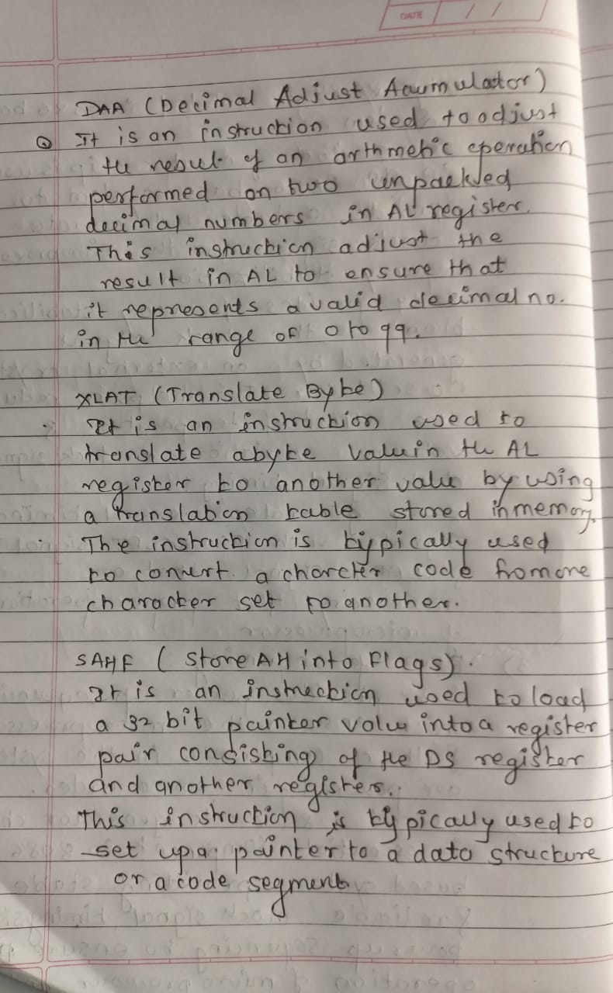

25.Explain string instructions of 8086?

String instructions are a set of instructions in the 8086 microprocessor that are used to manipulate strings of data. A string is a sequence of bytes or words stored in consecutive memory locations, and the string instructions allow for efficient manipulation of these sequences.

The main string instructions in the 8086 are:

1. MOVSB/MOVSW: These instructions move a byte or a word of data from the source memory location to the destination memory location, and then increment the source and destination pointers. For example, MOVSB copies a byte from DS:SI to ES:DI, while MOVSW copies a word (two bytes) from DS:SI to ES:DI.
2. CMPSB/CMPSW: These instructions compare a byte or a word of data at the source memory location with the byte or word of data at the destination memory location, and then increment the source and destination pointers. For example, CMPSB compares the byte at DS:SI with the byte at ES:DI, while CMPSW compares the word at DS:SI with the word at ES:DI.
3. REP/REPE/REPNE: These are prefixes that are used with string instructions to repeat the instruction a specified number of times or until a condition is met. For example, REP MOVSB repeats the MOVSB instruction until CX becomes zero.

These string instructions are commonly used in string operations such as string copy, string comparison, and string search. They can also be used in other applications where data is stored in consecutive memory locations.

26.Write a program to ADD/SUB two 16 bit number. [5M]

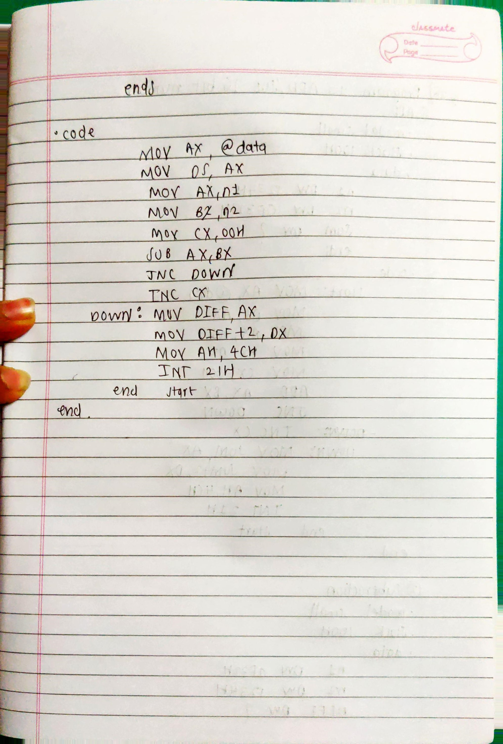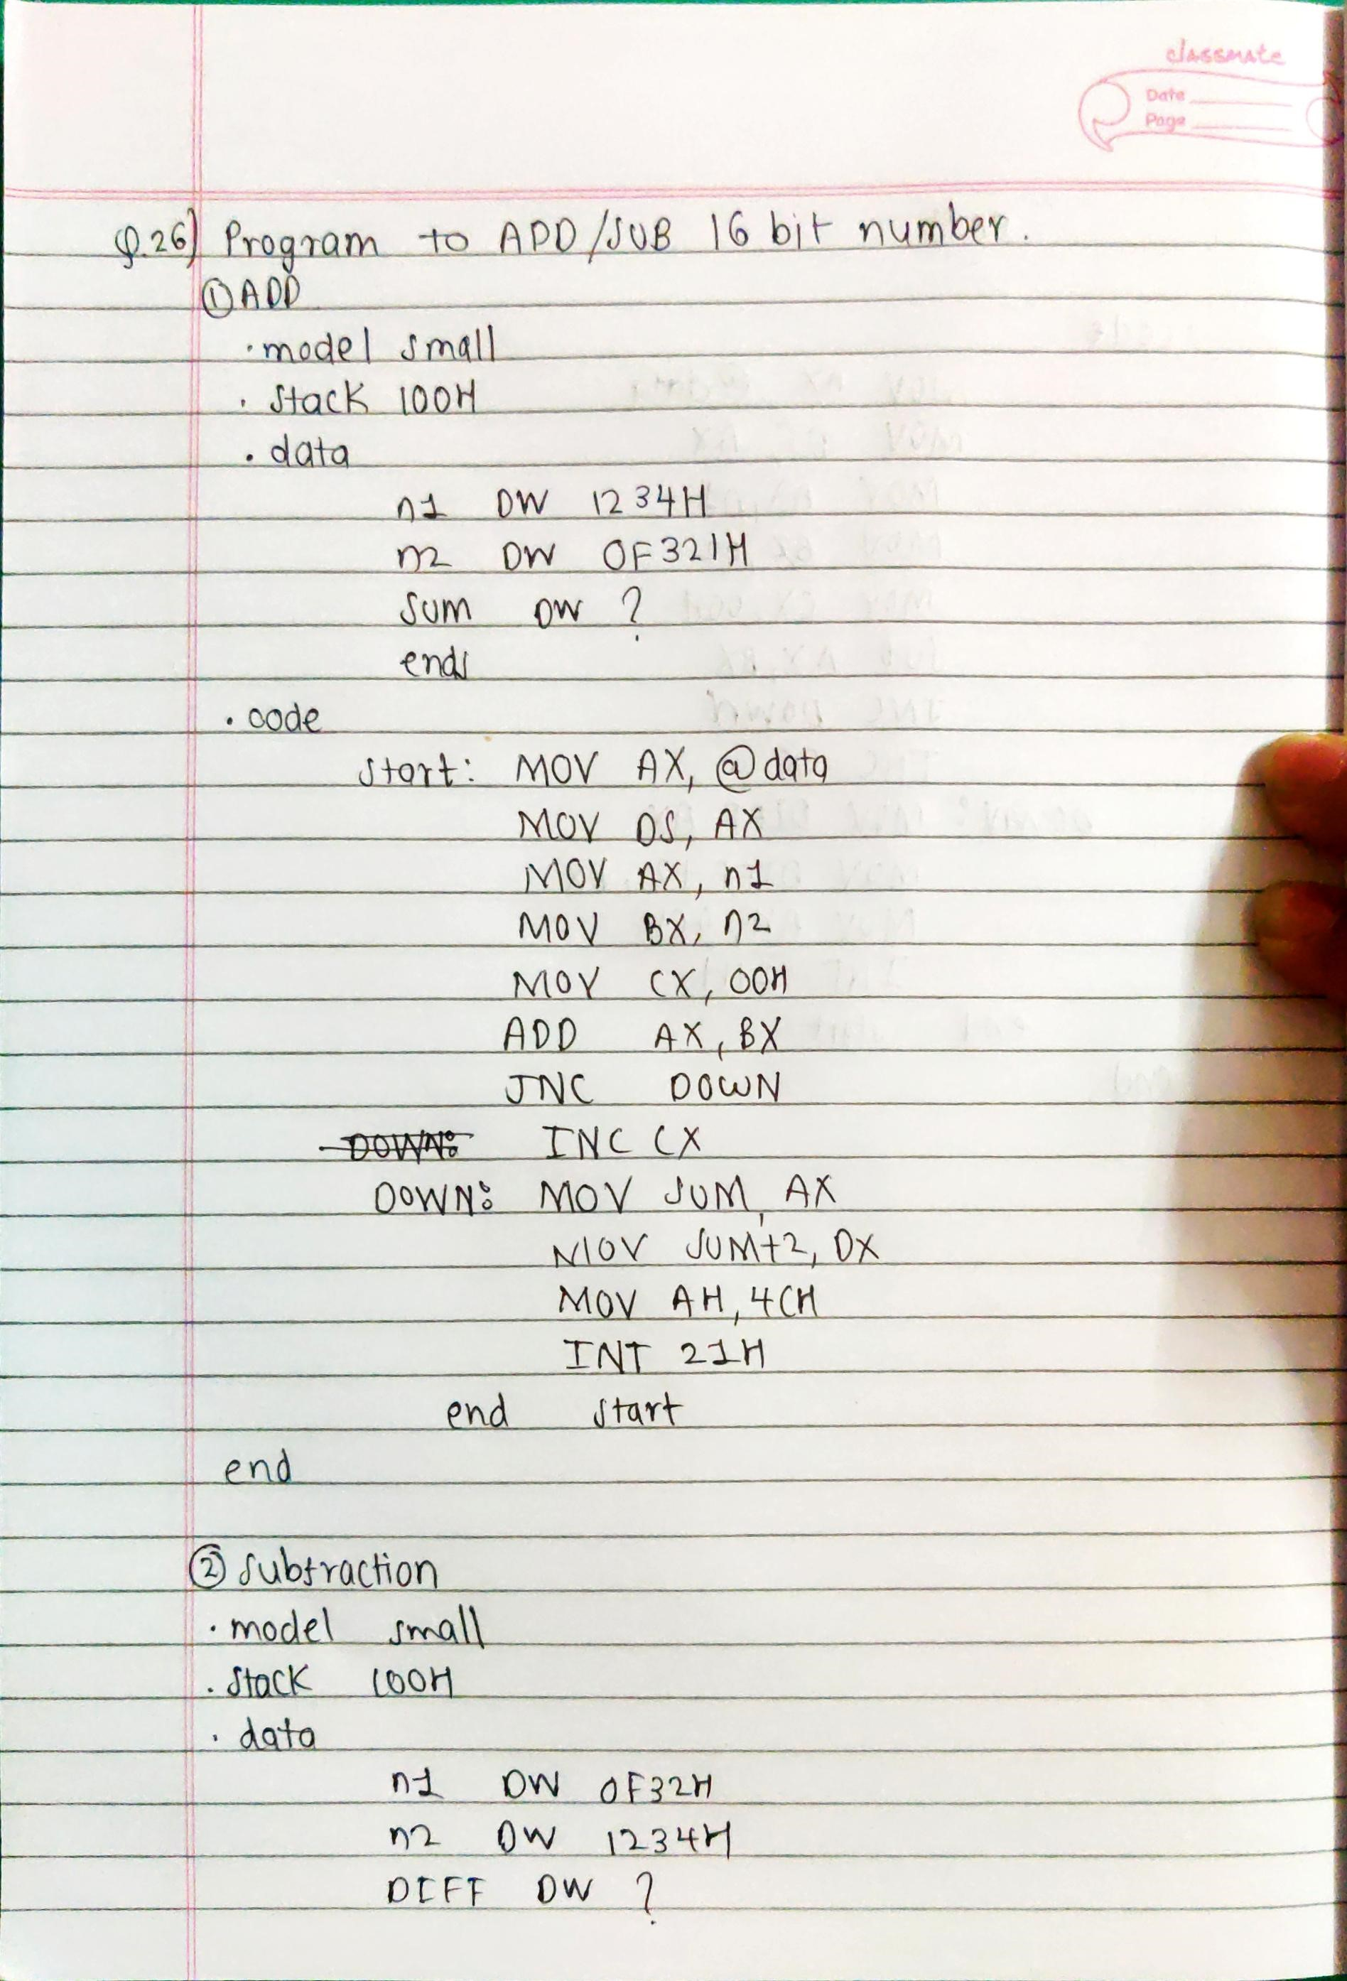

27.What is Assembler directives? Explain DB, SEGMENT, ENDS, .MODEL SMALL[5M]

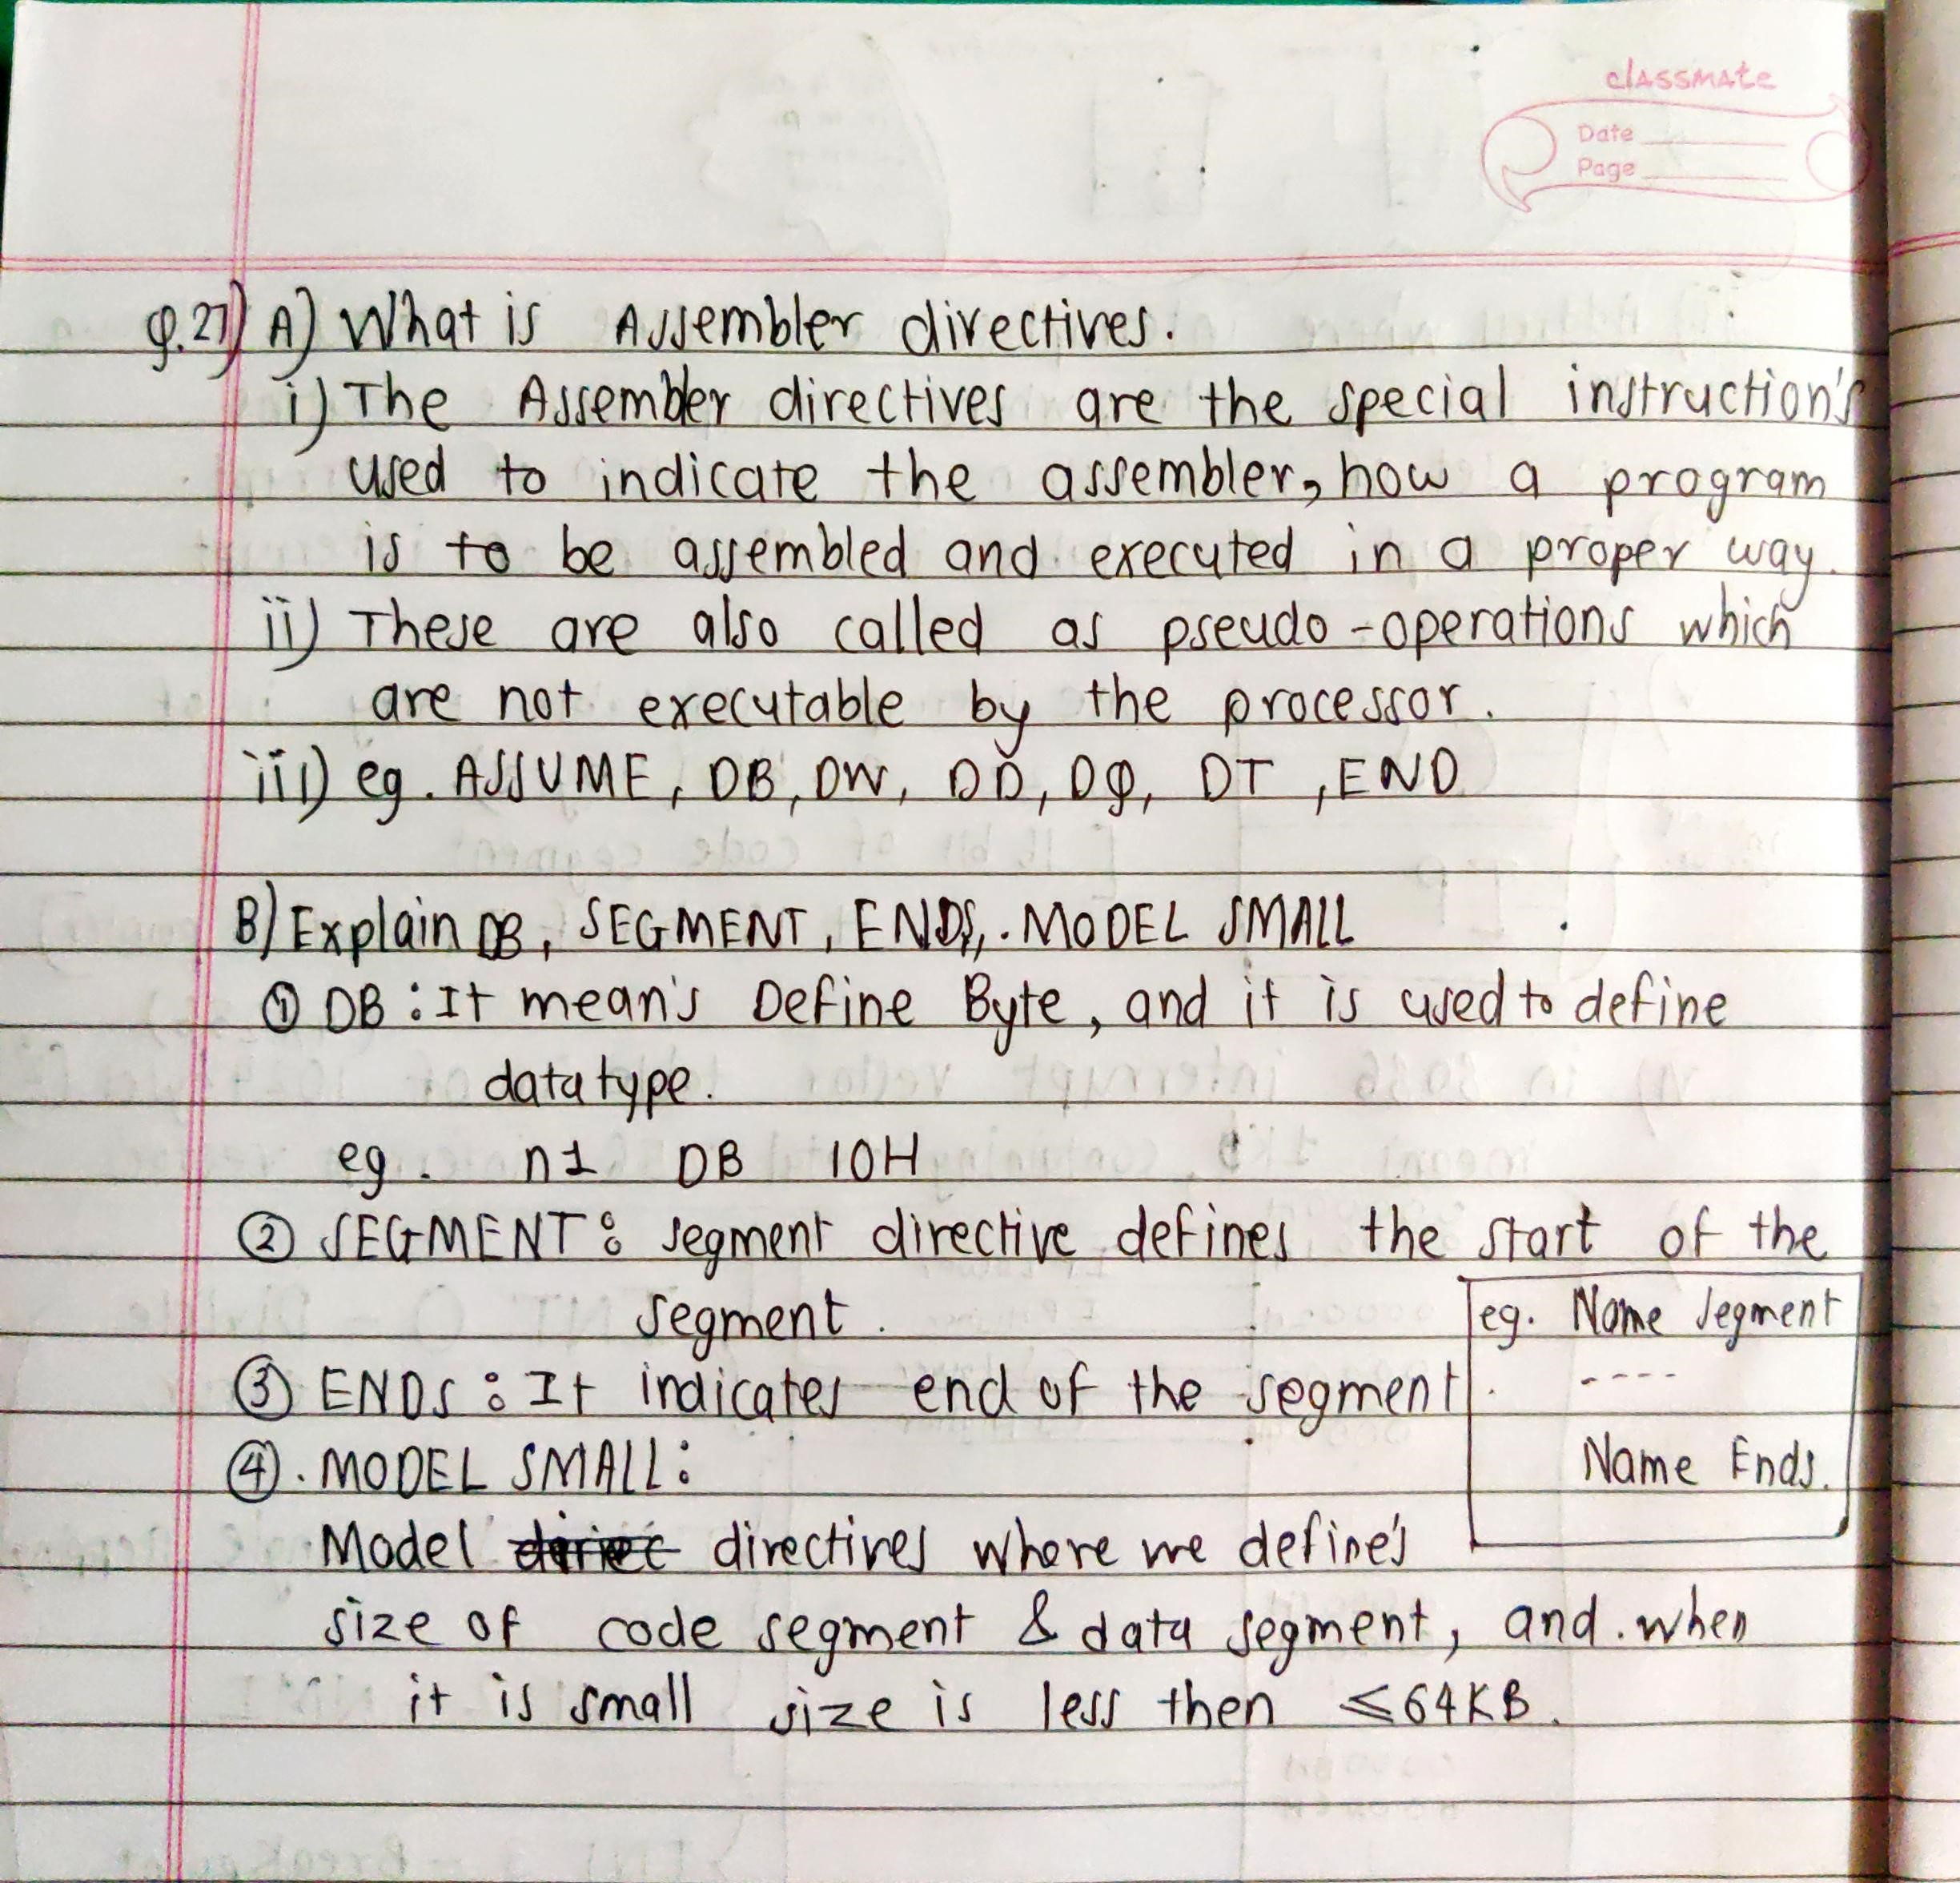Ans.

28.Write assembly language program to transfer data stored in data segment to extra segment.[2M]

DATA SEGMENT

DB 'Hello, World!', 0

DATA ENDS

EXTRA SEGMENT

DB 20 DUP(?)

EXTRA ENDS

CODE SEGMENT

ASSUME CS:CODE, DS:DATA, ES:EXTRA

START:

MOV AX, DATA ; Set DS to point to the data segment

MOV DS, AX

MOV AX, EXTRA ; Set ES to point to the extra segment

MOV ES, AX

MOV CX, 13 ; Set CX to the number of bytes to copy

MOV SI, 0 ; Set SI to point to the start of the data segment

MOV DI, 0 ; Set DI to point to the start of the extra segment

REP MOVSB ; Copy CX bytes from [DS:SI] to [ES:DI]

MOV AH, 4Ch ; Set AH to terminate the program

INT 21h

CODE ENDS

END START

In this program, the data to be transferred is stored in the **DATA** segment, and the destination memory is allocated in the **EXTRA** segment. The **MOVSB** instruction is used in conjunction with the **REP** prefix to copy the data from the data segment to the extra segment.

The program first sets the **DS** and **ES** registers to point to the data segment and extra segment, respectively. It then initializes the **CX** register to the number of bytes to be copied, and sets the **SI** and **DI** registers to point to the start of the data segment and extra segment, respectively.

The **REP MOVSB** instruction then copies the data from the source address **[DS:SI]** to the destination address **[ES:DI]**, incrementing the **SI** and **DI** registers and decrementing the **CX** register with each iteration. Once all of the data has been transferred, the program terminates with an interrupt call to **INT 21h**.

Top of Form

Regenerat

Bottom of Form